Name

Mathematics Stage 5 Path
Non-Right-Angled
Trigonometry

Book 2 | Apply the sine and cosine rules to any triangle and solve related problems | Version: 260409  Feedback:  https://MrDingMaths.com
Contents
Syllabus Content 2
Labelling Triangles 3
Sine Rule for Sides 5
Sine Rule for Angles 12
Cosine Rule for Sides 18
Cosine Rule for Angles 25
Area of a Triangle using Trigonometry 31
Selecting an Appropriate Method 38
Mixed Multistep Trigonometry Problems 44
Mixed Trigonometry Problems involving Bearings 50

Syllabus Content
MA5-TRG-P-01 applies Pythagoras’ theorem and trigonometry to solve 3-dimensional problems and applies the sine, cosine and area rules to solve 2-dimensional problems, including bearings
Apply the sine, cosine and area rules to any triangle and solve related problems
- Use graphing applications to verify the sine rule $\frac{a}{\sin{A}}=\frac{b}{\sin{B}}=\frac{c}{\sin{C}}$ and that the ratios of a side to the sine of the opposite angle is a constant
- Apply the sine rule in a given triangle $ABC$to find the value of an unknown side
- Apply the sine rule in a given triangle $ABC$to find the value of an unknown angle (ambiguous case excluded): $\frac{\sin{A}}{a}=\frac{\sin{B}}{b}=\frac{\sin{C}}{c}$
- Use graphing applications to verify the cosine rule $c^{2}=a^{2}+b^{2}-2ab\cos{C}$.
- Apply the cosine rule to find the unknown sides for a given triangle $ABC$.
- Rearrange the formula to deduce that $\cos{C}=\frac{a^{2}+ b^{2}- c^{2}}{2ab}$ and use this to find an unknown angle
- Use graphing applications to verify the area rule $A=\frac{1}{2}ab\sin{C}$.
- Apply the formula $A=\frac{1}{2}ab\sin{C}$, where $a$ and $b$ are the sides that form angle $C$ to find the area of a given triangle $ABC$
- Solve problems involving finding unknown angles or sides in triangles (excluding right-angled triangles) by selecting and applying the appropriate rule

Labelling Triangles

- Labelling Triangles
In a triangle, lowercase letters represent sides and uppercase letters represent angles.
Each side is named with the same letter as the angle opposite to it.
Side $a$ is opposite angle $A$. Side $b$ is opposite angle $B$. Side $c$ is opposite angle $C$.
Opposite sides and angles do not touch.
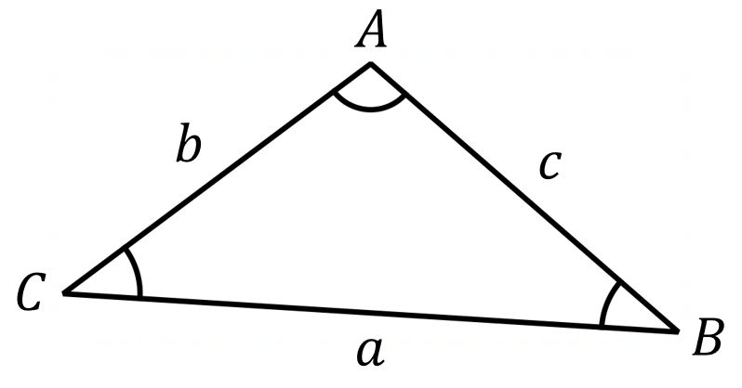

- We label a vertex (corner) of a triangle and the angle at that vertex using the same uppercase letter.

- Identify Triangle opposite angle/side pairs
Label the missing sides/angles of these triangles.
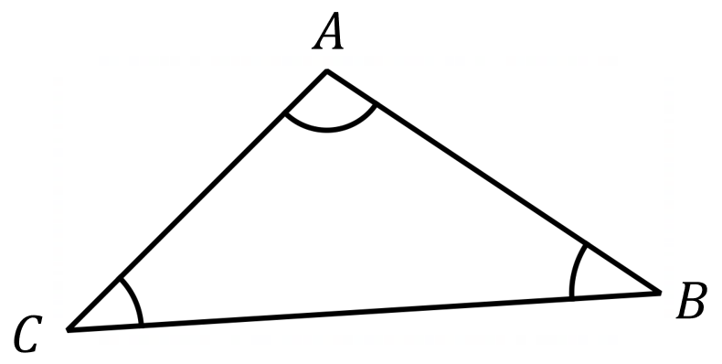
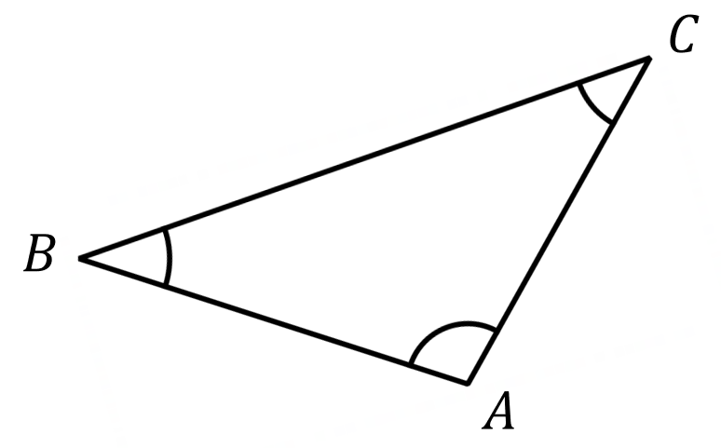

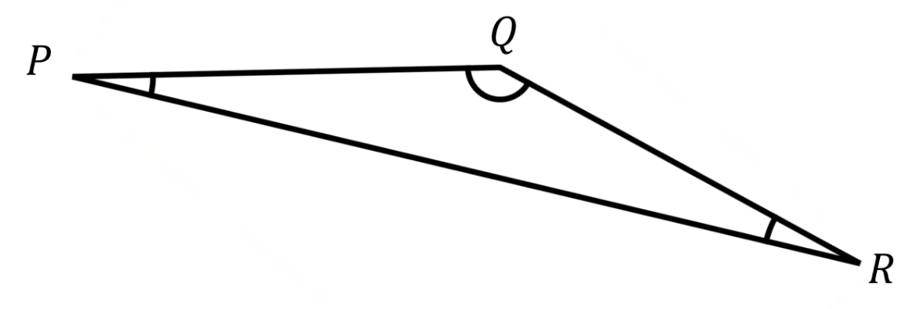 | 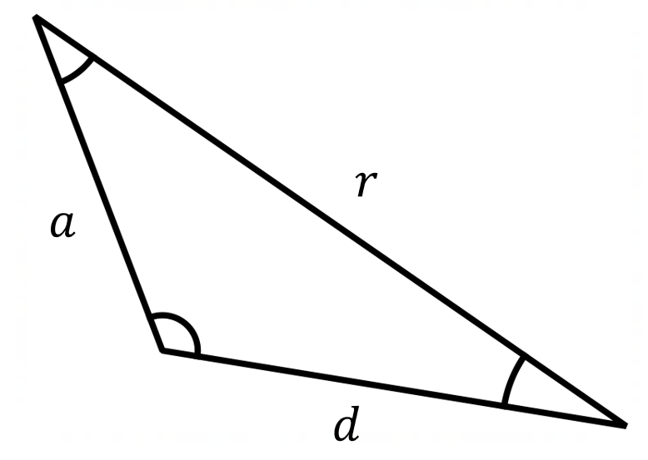

- Key Ideas
- In a triangle, each side is named with the same ……………… letter as its opposite angle.
- Side $a$ is opposite angle ……, side …… is opposite angle $B$.
- To find which angle is opposite a side, look for the angle that the side does NOT …………

Foundation

- Label the side opposite angle $C.$  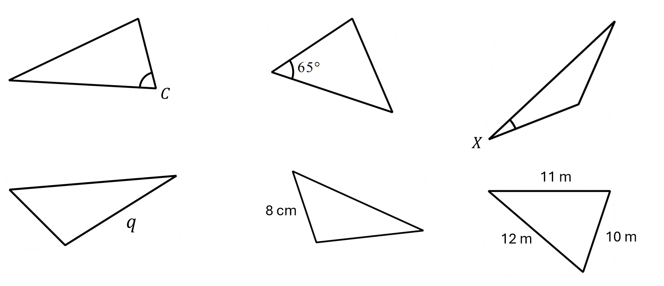  $$c$$  $$c$$ | - Label the angle opposite side $q$  $$Q$$ | - Label the side opposite the 65° angle $x$  $$x$$
- Use $θ$ to label the angle opposite the 8 cm side  $$θ$$ | - Use $x$ to label the side opposite the $40°$ angle  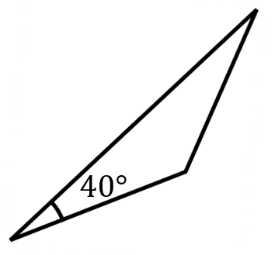  $$x$$ | - Use $θ$ to label the angle opposite the 12 m side  $$θ$$

- Label the missing sides and angles of these triangles.
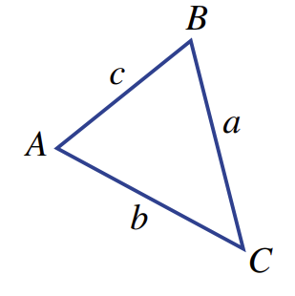  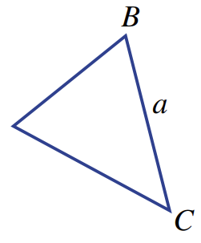 | 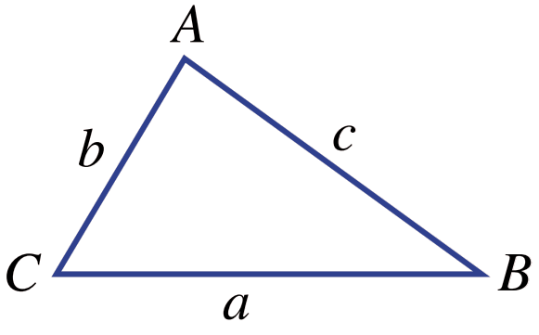  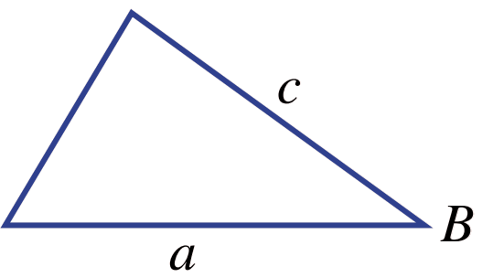
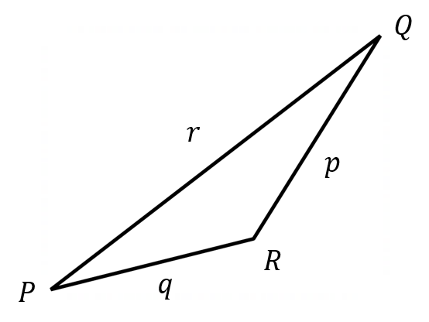
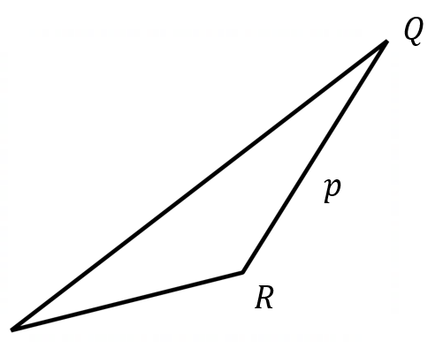

Sine Rule for Sides

- Review
- Identify the side/angle opposite in a triangle
- Which side is opposite angle $θ$?  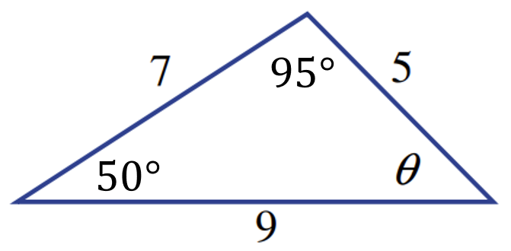 | - Which angle is opposite side $c$?  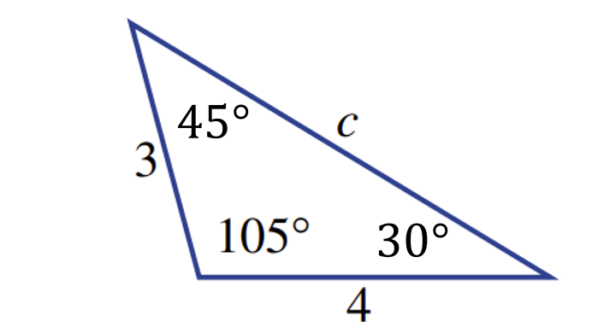

- Solve proportion equations
Round answers to 1 d.p. where necessary
$$\frac{x}{7}=\frac{12}{5}$$ | $$\frac{8}{x}=\frac{15}{11}$$ | $$\frac{x}{\sin{40°}}=\frac{8}{\sin{65°}}$$
$$\frac{x}{\sin{35°}}=\frac{12}{\sin{48°}}$$ | $$\frac{22}{\sin{45°}}=\frac{x}{\sin{60°}}$$ | $$\frac{\sin{72°}}{15}=\frac{\sin{35°}}{x}$$

- Sine Rule
In any triangle:
- The longest side is opposite the largest angle.
- The shortest side is opposite the smallest angle.
We express this relationship mathematically using the sine rule:
$$\frac{a}{\sin{A}}=\frac{b}{\sin{B}}=\frac{c}{\sin{C}}$$

To use the sine rule to find a side, you need:
- A complete ‘opposite pair’ – one side AND its opposite angle (both known).
- The opposite angle to the side you want to find.
- You need just TWO fractions from the sine rule: one for the known pair, one for the unknown side.

- Identify whether you can use sine rule to find a side
✖  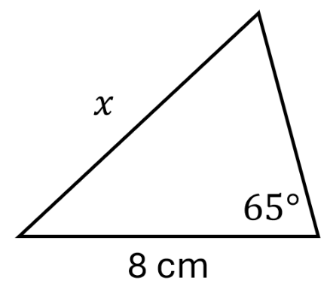 | ✔  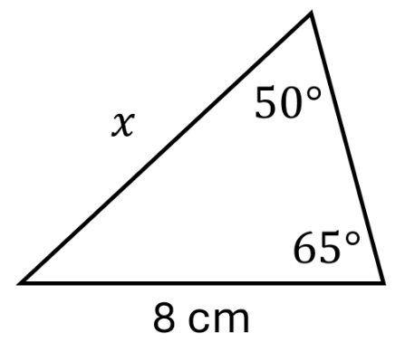 | ✔  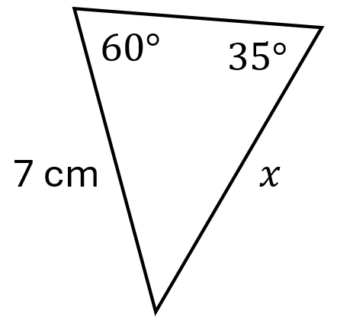 | ✖  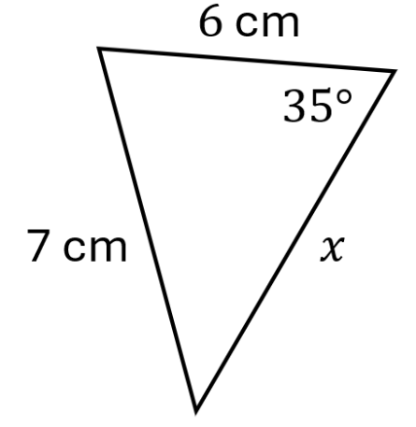
Identify whether you can use sine rule to find the missing side.
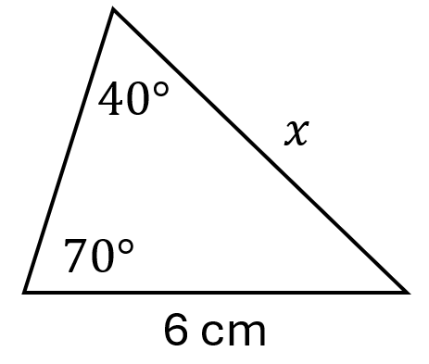 | 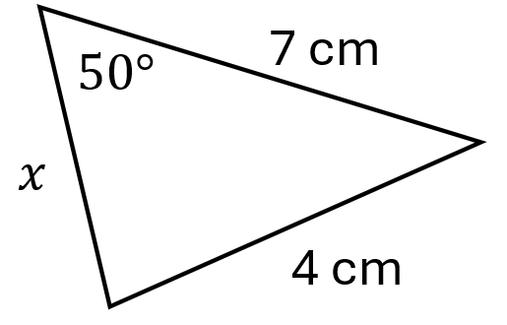 | 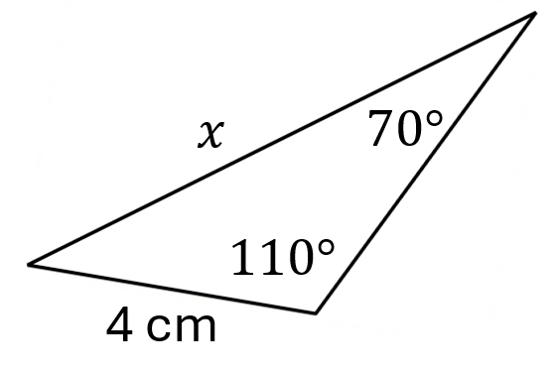 | 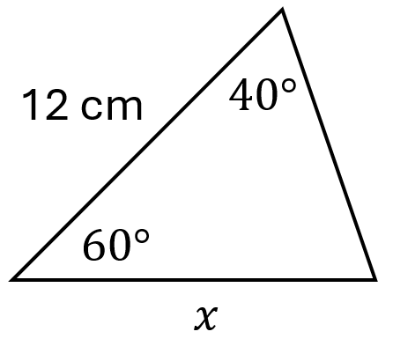

- Key Ideas
- To use the sine rule to find a side, you need a complete …………………… and the …………… opposite the side you want to find.
- An ‘…………… ………’ consists of a ……………… and the …………… opposite to it.

- Sine Rule (Finding a Side)

$$\frac{a}{\sin{A}}=\frac{b}{\sin{B}}=\frac{c}{\sin{C}}$$

- Write sine rule equation from a diagram
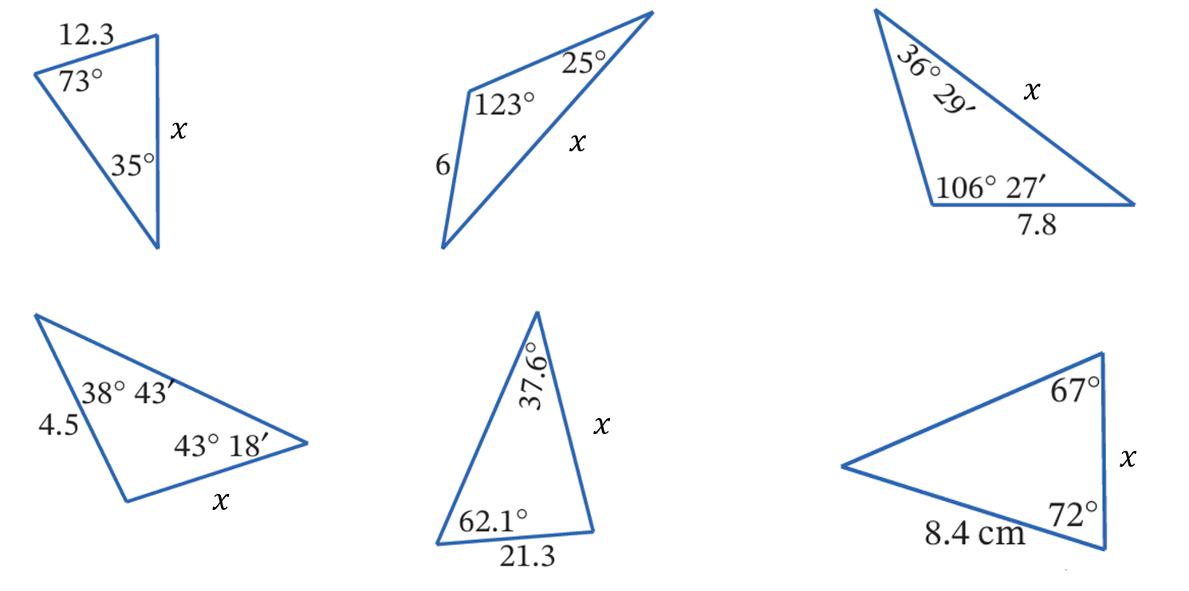

$$\frac{x}{\sin{73°}}=\frac{12.3}{\sin{35°}}$$

- Sine Rule (Finding a Side)
$$\frac{a}{\sin{A}}=\frac{b}{\sin{B}}=\frac{c}{\sin{C}}$$

- Example Calculate a side length using sine rule
Find the length of the missing side, to 1 d.p.
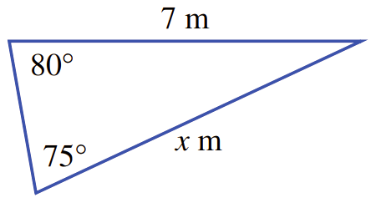
$$\frac{x}{\sin{80°}}=\frac{7}{\sin{75°}} \\ ×\sin{80°}=×\sin{80°} \\ x=\frac{7\sin{80°}}{\sin{75°}} \\ ≈7.1 m$$

- Guided Practice
Find the length of the missing side, to 1 d.p.
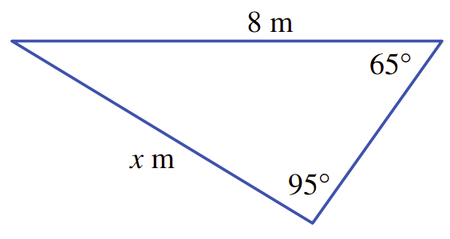  7.3 m | 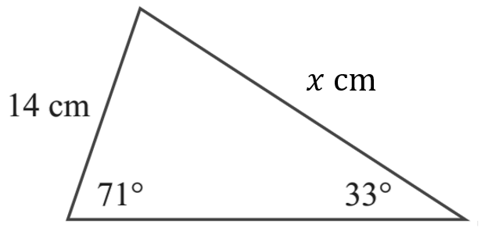  24.3 cm

Foundation
- Solve each equation for the unknown, correct to 2 decimal places.
$$\frac{a}{\sin{47°}}=\frac{2}{\sin{51°}}$$  1.88 | $$\frac{b}{\sin{31°}}=\frac{7}{\sin{84°}}$$  3.63 | $$\frac{5}{\sin{63°}}=\frac{c}{\sin{27°}}$$  2.55

- Find the value of the unknown in these triangles, correct to 1 decimal place.
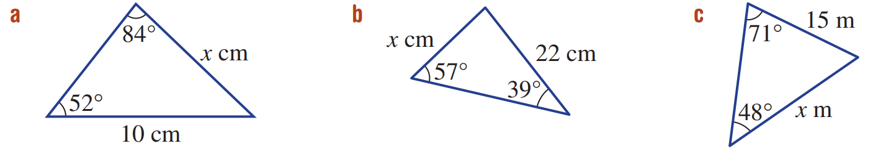  $$\frac{x}{\sin{52°}}=\frac{ }{ }$$  $x=$ …………  $=$ …………  7.9 | 16.5 | 19.1

- Calculate the side length $x$ using sine rule to 1 d.p.
(Hint: Angle sum of a triangle is $180°$)
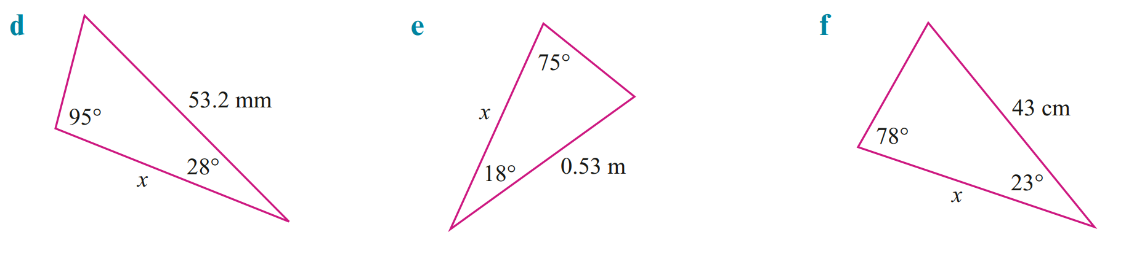  44.8 mm | 0.5 m | 43.2 cm

Development
- Calculate the side length $x$ using sine rule. Round your answer to 1 d.p.
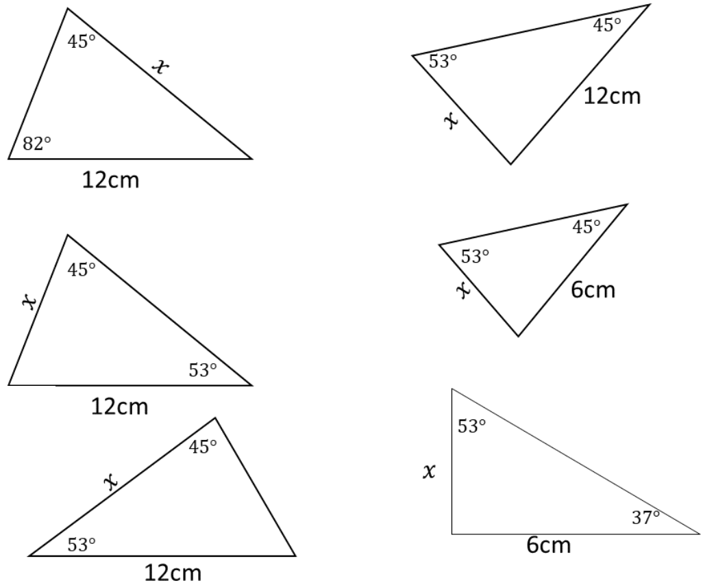  16.8 cm | 13.6 cm | 16.8 cm
10.6 cm | 5.3 cm | 4.5 cm

- Three markers, A, B and C, map out the course for a cross-country race.
Find the total distance of the race. Round your answer to 2 decimal places.
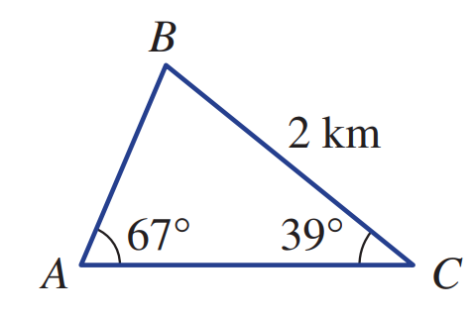

AB = 1.367 km, AC = 2.089 km, total length: 5.46 km

- A ship heads due north from point A for 40 km to point B, and then heads on a bearing of 100° to point C. The bearing from C to A is 240°.
  - Find $∠ABC$.
  - Hence find distance AC, to 1 d.p.
  - Hence find distance BC, to 1 d.p.
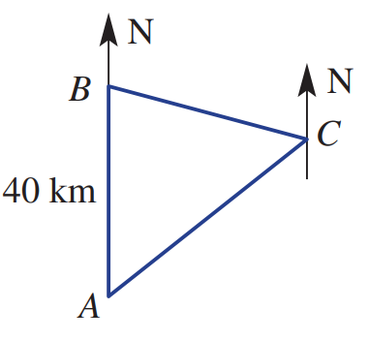

∠ABC = 80°
AC = 61.3 km
BC = 53.9 km

Mastery
- Proof of the Sine Rule
Consider the non-right-angled triangle shown.

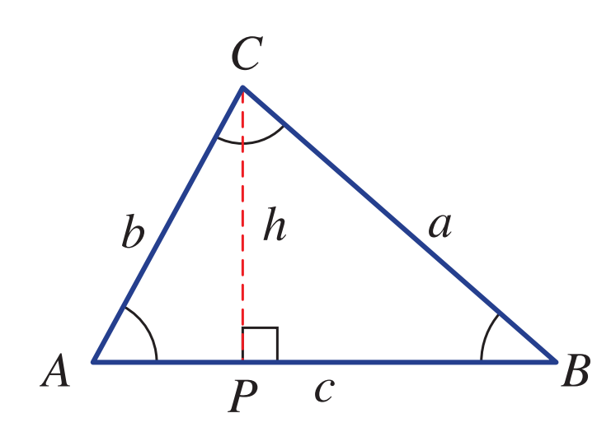
By looking at right-angled triangle $ΔCPB$,
$$\sin{B}=\frac{h}{a} \\ ∴h=$$
$$a\sin{B}$$

Similarly, from $ΔCPA$,

$$\sin{A}=\frac{h}{b} \\ ∴h=$$
$$b\sin{A}$$
By equating our two expressions for $h:$

$$a\sin{B}=b\sin{A} \\ ∴\frac{a}{\sin{A}}=$$
$$\frac{b}{\sin{B}}$$
By constructing a perpendicular line from vertex $B$ to $AC$and following the steps of the proof above, prove that:
$$\frac{a}{\sin{A}}=\frac{c}{\sin{C}}$$

Let the perpendicular from B meet AC at point Q.
$$In ΔCBQ,\sin{C}=\frac{BQ}{a}, ∴BQ=a\sin{C}$$
$$In ΔBAQ,\sin{A}=\frac{BQ}{c}, ∴BQ=c\sin{A}$$
$$∴a\sin{C}=c\sin{A}$$
$$\frac{a}{\sin{A}}=\frac{c}{\sin{C}}$$
Hence explain why:
$$\frac{a}{\sin{A}}=\frac{b}{\sin{B}}=\frac{c}{\sin{C}}$$

Since $\frac{a}{\sin{A}}=\frac{b}{\sin{B}}$ and $\frac{a}{\sin{A}}=\frac{c}{\sin{C}}$, all three are equal.

Sine Rule for Angles

- Review
- Round to the nearest minute
- $34° {40}^{'} 12''$ | - $24° {20}^{'} 34''$ | - $37° {49}^{'} 00''$ | - $11° {10}^{'} 49''$

- Solve trigonometric equations for an angle
Answer to the nearest minute
$$\sin{θ}=0.6248$$ | $$\sin{θ}=\frac{5}{12}$$ | $$\sin{θ}=\frac{4\sin{60°}}{15}$$
$$\frac{\sin{θ}}{20}=\frac{\sin{25°}}{18}$$ | $$\frac{\sin{77°}}{12}=\frac{\sin{θ}}{6}$$ | $$\frac{11}{\sin{θ}}=\frac{17}{\sin{30°}}$$

- Sine Rule (Finding an Angle)
$$\frac{\sin{A}}{a}=\frac{\sin{B}}{b}=\frac{\sin{C}}{c}$$

To use the sine rule to find an angle, you need:
- A complete ‘opposite pair’ – one side AND its opposite angle (both known).
- The opposite side to the angle you want to find.

- Identify whether you can use sine rule to find an angle
✖  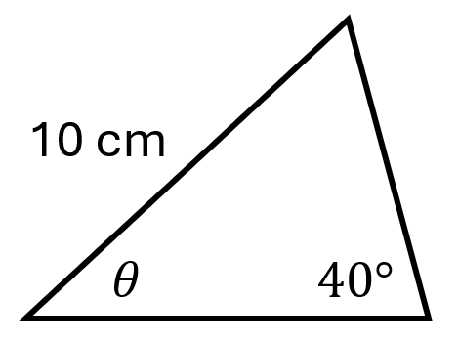 | ✔  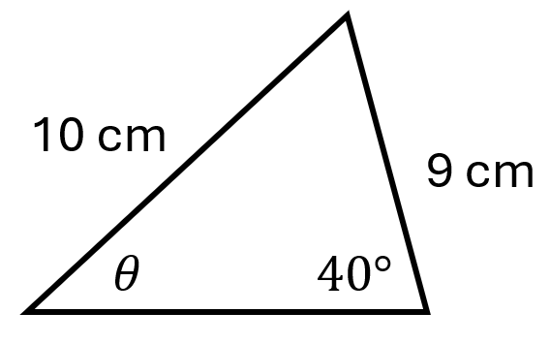 | ✔  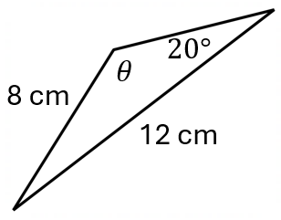 | ✖  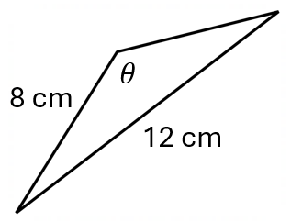
Identify whether you can use sine rule to find the missing angle.
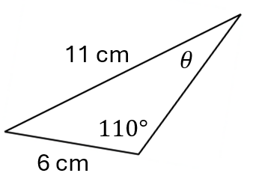 | 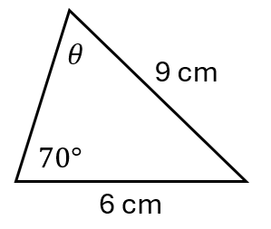 | 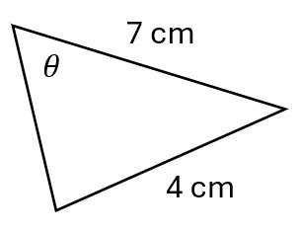 | 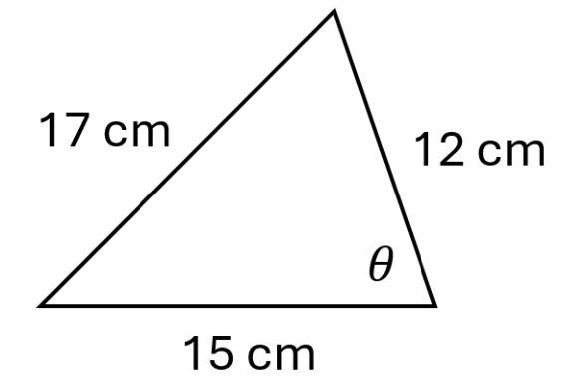

- Sine Rule (Finding an Angle)
When finding an angle, have sin in the numerator.
This makes it easier to solve for an angle.

$$\frac{\sin{A}}{a}=\frac{\sin{B}}{b}=\frac{\sin{C}}{c}$$

- Example Calculate an angle using sine rule
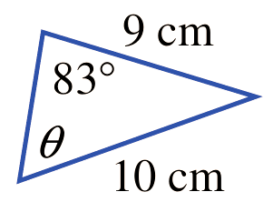
Find the missing angle to the nearest minute.
$$\frac{\sin{θ}}{9}=\frac{\sin{83°}}{10} \\ ×9=×9 \\ \sin{θ}=\frac{9\sin{83°}}{10} \\ θ=\sin^{-1}\left(\frac{9\sin{83°}}{10}\right) \\ ≈63°17'$$

- Guided Practice
Find the missing angle to the nearest minute.
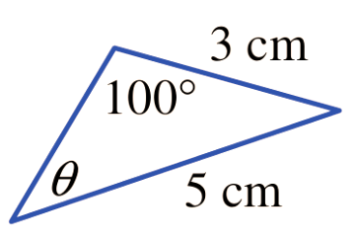  36° 13’ | 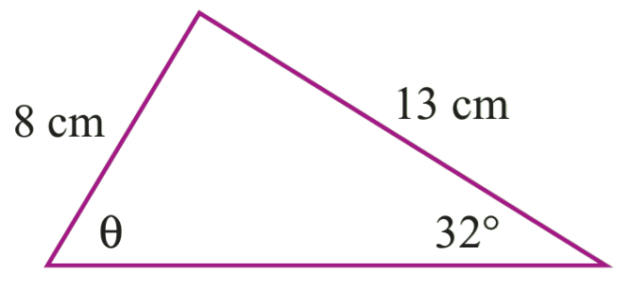  59° 27’
- Sine Rule (Finding an Obtuse Angle)
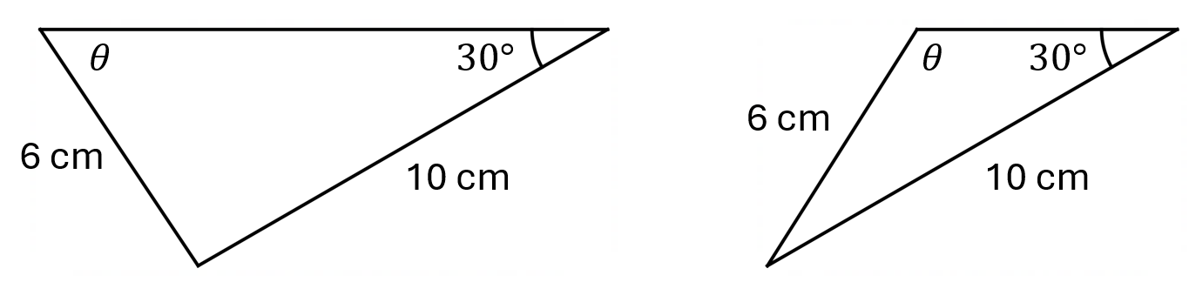
Given two sides and one angle, it is sometimes possible to make 2 triangles:

This is due to the identity: $\sin{θ}=\sin{(180°-θ)}$
The calculator will always give the acute angle when using $\sin^{-1}{( )}$
To get the obtuse angle, subtract the result from 180: $180°-θ$
You will learn the reason for this if you study Mathematics Advanced

- Example Calculate an angle using sine rule
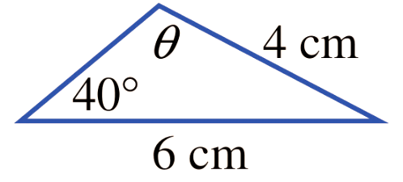
Find the missing angle to the nearest degree, given it is obtuse.
$$\frac{\sin{θ}}{6}=\frac{\sin{40°}}{4} \\ ×6=×6 \\ \sin{θ}=\frac{6\sin{40°}}{4} \\ θ=\sin^{-1}\left(\frac{6\sin{40°}}{4}\right) \\ ≈75° \\ ∴θ=180°-75°=105°$$

- Guided Practice
Find the missing angle to the nearest degree, given it is obtuse.
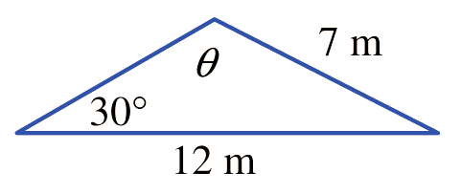  121° | 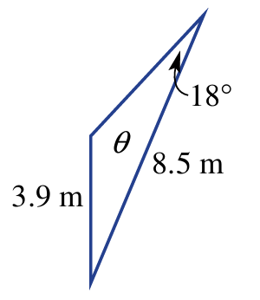  138°

Foundation
- Solve each equation for the unknown, correct to the nearest minute.
$$\frac{\sin{38°}}{4}=\frac{\sin{θ}}{5}$$  50° 19' | $$\frac{\sin{51°}}{11}=\frac{\sin{θ}}{9}$$  39° 29' | $$\frac{12}{\sin{θ}}=\frac{18}{\sin{47°}}$$  29° 11'

- Find the value of the unknown in these triangles, correct to 1 decimal place.
$$\frac{\sin{θ}}{5}=\frac{ }{ }$$  $\sin{θ}=$ …………  $θ=$ …………  38.0° | 51.5° | 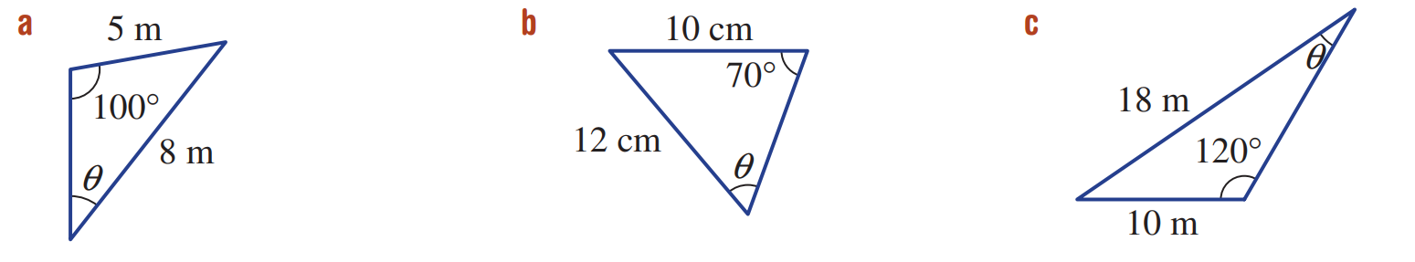  28.8°

- Calculate the unknown obtuse angle $θ$. Answer to 1 d.p.
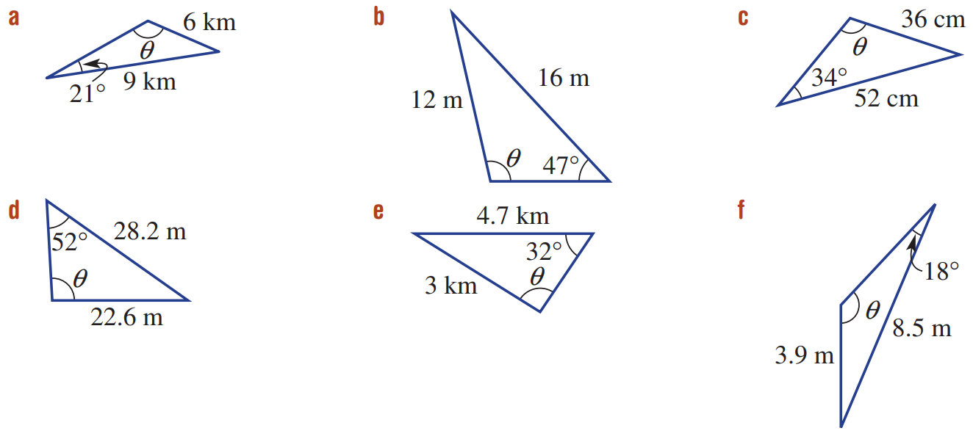  147.5° | 126.1° | 123.9°

Development
- Calculate the unknown obtuse angle $∠A$. Answer to nearest minute.
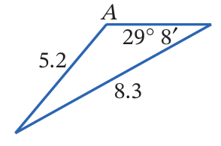  129° 0′ | 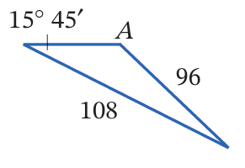  162° 13′ | 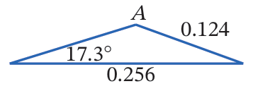  142° 8′

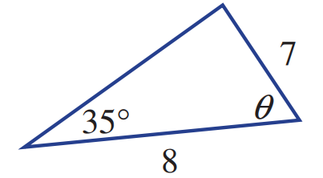
- Ryan trying to solve this problem. He wrote $\frac{\sin{35°}}{7}=\frac{\sin{θ}}{8}$.
  - Explain why he is incorrect.

$θ$ is not opposite the 8
  - Solve for $θ$by finding the missing information first.

Find top angle using sine rule, $ϕ=40°58'$
$$θ=180-35-40°58'=104°2'$$

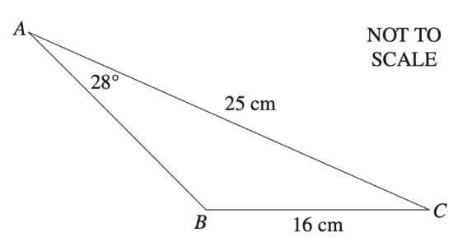
- 2021 HSC Standard 2 Band 5
Find obtuse $∠ABC$ to the nearest degree.

133°

Cosine Rule for Sides

- Review
- Solve quadratic equations
Answer to 1 d.p.
$$x^{2}=7^{2}+{11}^{2}-2\left(7\right)\left(11\right)\cos{60°}$$ | $$x^{2}=8^{2}+{15}^{2}-2\left(8\right)\left(15\right)\cos{45°}$$

- Included Angle
The included angle is the angle between two given sides.
✖  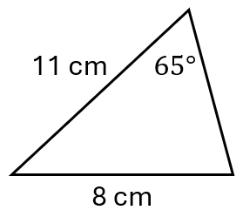 | ✔  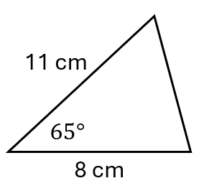 | ✔  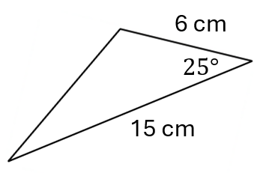 | ✖  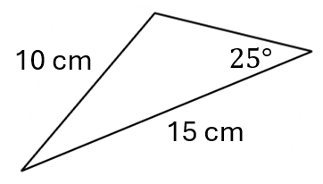

- Cosine Rule (Finding a Side)
The cosine rule is Pythagoras’ theorem, generalised for non-right-angled triangles.

$$c^{2}=a^{2}+b^{2}-2ab\cos{C}$$

To use the cosine rule to find a side, you need:
- Two given sides.
- The included angle, $C$, which is opposite the side you want to find.

- Identify whether you can use cosine rule to find a side
✖  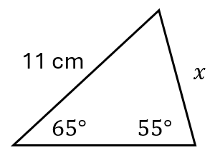 | ✔  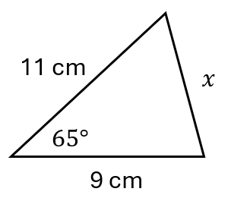 | ✔  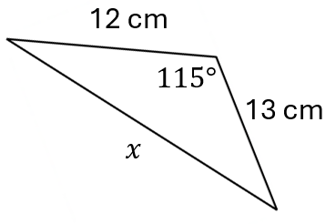 | ✖  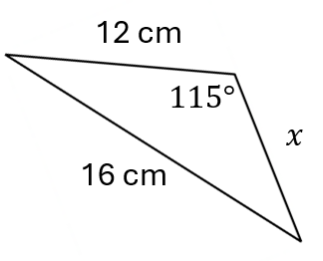
Identify whether you can use cosine rule to find the missing side.
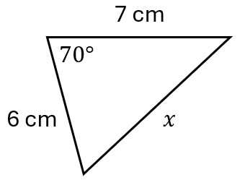 | 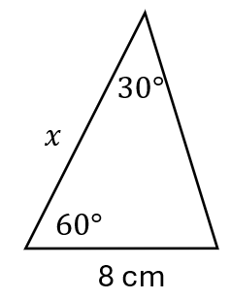 | 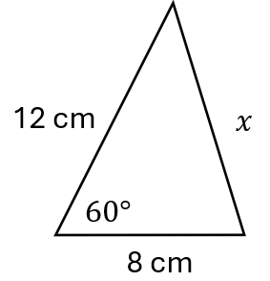 | 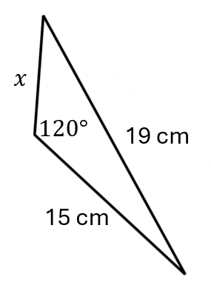

- Cosine Rule (Finding a Side)

$$c^{2}=a^{2}+b^{2}-2ab\cos{C}$$

- Write Cosine rule equation from a diagram
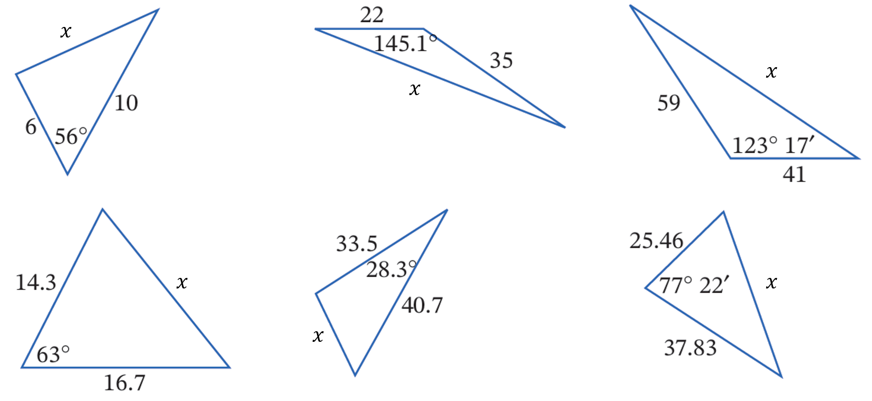

$$x^{2}=6^{2}+{10}^{2}-2\left(6\right)\left(10\right)\cos{56°}$$

- Cosine Rule (Finding a Side)

$$c^{2}=a^{2}+b^{2}-2ab\cos{C}$$

- Example Calculate a side using cosine rule
Calculate the length of $x$ to 2 d.p.
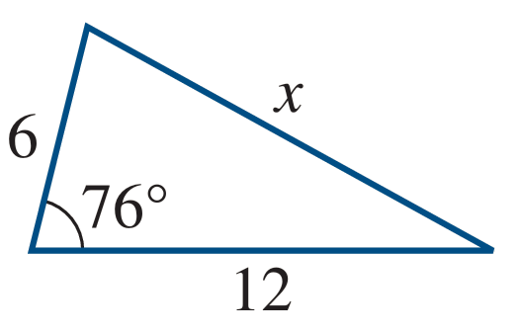
$$c^{2}=a^{2}+b^{2}-2ab\cos{C} \\ x^{2}=6^{2}+{12}^{2}-2\left(6\right)\left(12\right)\cos{76°} \\ x=\sqrt{6^{2}+{12}^{2}-2\left(6\right)\left(12\right)\cos{76°}} \\ ≈12.05$$

- Guided Practice
Calculate the length of $x$ to 2 d.p.
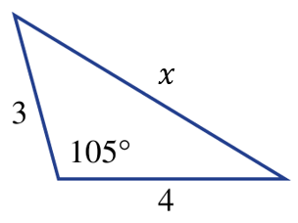  5.59 | 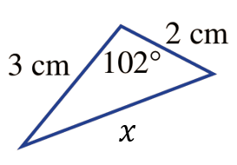  3.94

Foundation
- Solve for the unknown value in these equations. Answer to 2 d.p.
- $x^{2}=4^{2}+7^{2}-2\left(4\right)\left(7\right)\cos{120°}$  $$9.64$$ | - $x^{2}={1.5}^{2}+{1.1}^{2}-2\left(1.5\right)\left(1.1\right)\cos{70°}$  1.53

- Find the length of the unknown side in these triangles, correct to 2 decimal places.
$x^{2}={\left( \right)}^{2}+{\left( \right) }^{2}-2\left( \right)\left( \right)\cos{( )}$  $x=\sqrt{ }$  $x=$ ……………  16.07 cm | 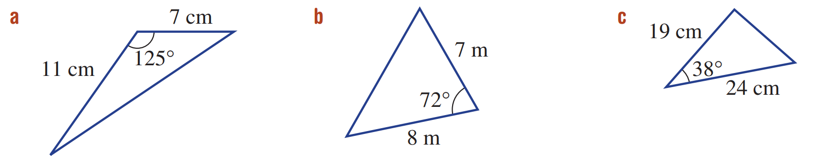  8.85 m
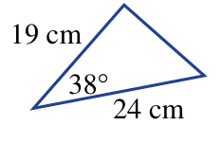  14.78 cm | 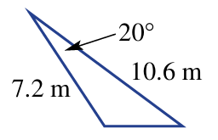  4.56 m

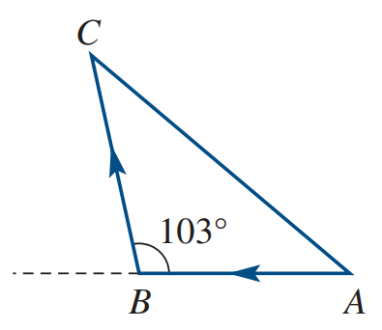
- Ruby drives along a 14 km track from point $A$ due west to a point $B$.
She then turns and travels 19 km to point $C$.
Calculate the distance from her starting point. Answer correct to one decimal place.

26.0 km

Development
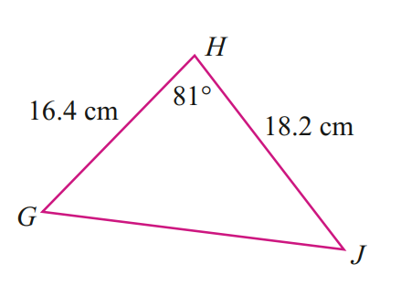
- Calculate the perimeter of this triangle to 1 d.p.

GJ = 22.5 cm, Perimeter = 57.1 cm
- A triangular goat paddock has two sides of lengths 320 m and 170 m, and a 71° angle between them. Find the length of the third side, correct to the nearest metre.

310 m
- The viewing angle to a vertical screen is 18° and the distances between the viewing point, P, and the top and bottom of the screen are 25 m and 23 m, respectively.
Find the height of the screen ($x$ m), correct to the nearest centimetre.
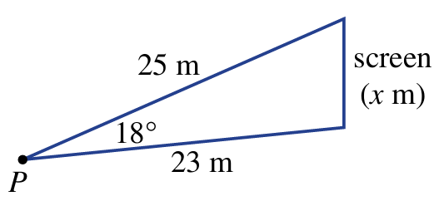

7.76 m (or 776 cm)

- Find the length of the missing side to 1 d.p. by using cosine rule, then check your answer using sine rule.
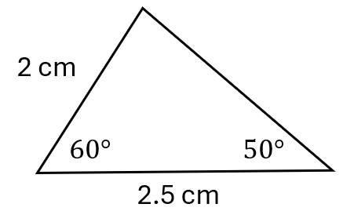
Cosine rule:
$$c² = 2² + 2.5² - 2(2)(2.5) cos 60°$$
$$c = 2.3 cm$$
Sine rule:
$$\frac{c}{\sin{60°}} =\frac{2}{\sin{50°}}$$
$$c =\frac{2\sin{60°}}{\sin{50°}}$$
$$c = 2.3 cm$$

Mastery
- Proof of the Cosine Rule
Consider the non-right-angled triangle shown.

Write an expression for length $AP$

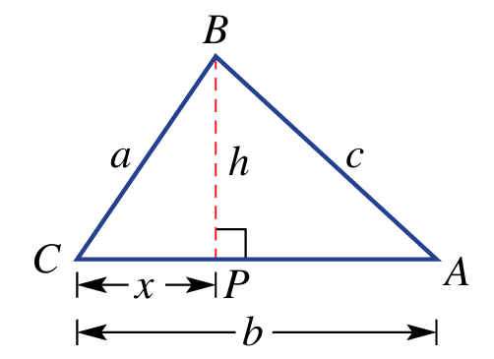
$$b-x$$
Use Pythagoras’ Theorem in $ΔCBP$ to write an
equation relating $c, x$, and $h$

$$x^{2}+h^{2}=a^{2}$$
Use Pythagoras’ Theorem in $ΔABP$ to write an
equation relating $b, a$, $x$, and $h$

$${\left(b-x\right)}^{2}+h^{2}=c^{2}$$

By making $h^{2}$ the subject of your two equations above, eliminate $h$ and simplify your result.
$h^{2}=a^{2}-x^{2}$ and
$$h^{2}=c^{2}-{\left(b-x\right)}^{2}$$

$$a^{2}-x^{2}=c^{2}-{\left(b-x\right)}^{2}$$
$$a^{2}-x^{2}=c^{2}-\left(b^{2}-2bx+x^{2}\right)$$
$$a^{2}-x^{2}=c^{2}-b^{2}+2bx-x^{2}$$
$$a^{2}=c^{2}-b^{2}+2bx$$

Use $\cos{θ}=\frac{Adjacent}{Hypotenuse}$ to write an expression for $\cos{C}$.

$$\cos{C}=\frac{x}{a}$$

Combine your equations from the two parts above to prove cosine rule
$$c^{2}=a^{2}+b^{2}-2ab\cos{C}$$

$$x=a\cos{C}$$
$$a^{2}=c^{2}-b^{2}+2ab\cos{C}$$
$$∴c^{2}=a^{2}+b^{2}-2ab\cos{C}$$

Cosine Rule for Angles

- Review
- Solve trigonometric equations for an angle
Answer to the nearest minute
$$\cos{θ}=\frac{{12}^{2}+5^{2}-8^{2}}{2(12)(5)}$$ | $$\cos{θ}=\frac{{11}^{2}+5^{2}-7^{2}}{2(11)(5)}$$

- Cosine Rule
We can rearrange the cosine rule to find an angle.

$$\cos{C}=\frac{a^{2}+b^{2}-c^{2}}{2ab}$$

To use the cosine rule to find an angle, you need the lengths of all three sides.
✖  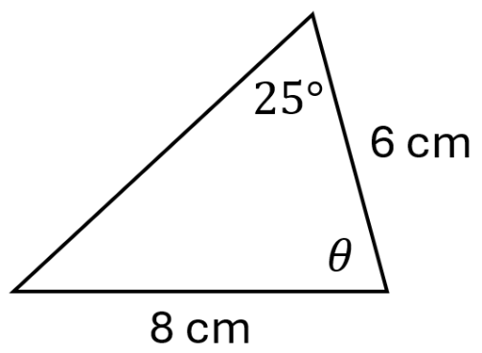 | ✔  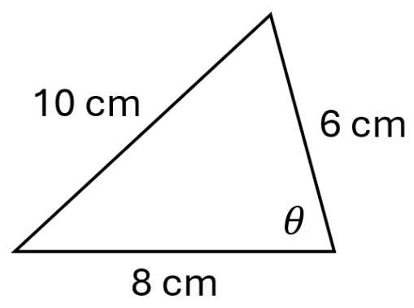 | ✔  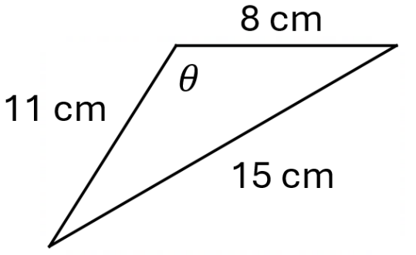 | ✖  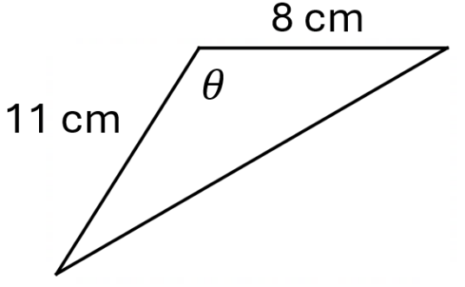

- Cosine Rule (Finding an Angle)
$c$ is always the side OPPOSITE the angle you want to find.
The other two sides are $a$ and $b$ (order doesn't matter).
$$\cos{C}=\frac{a^{2}+b^{2}-c^{2}}{2ab}$$

- Write Cosine rule equation from a diagram
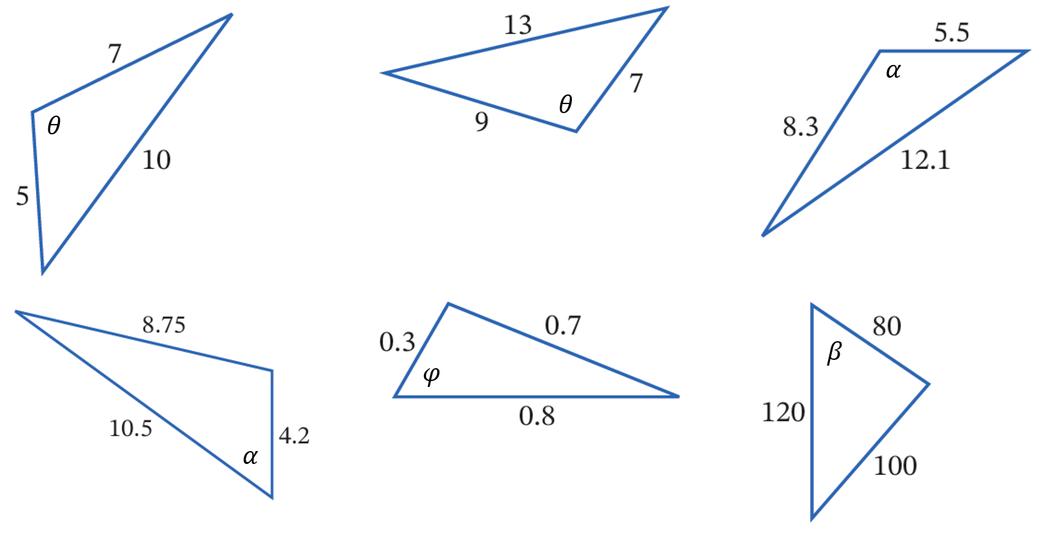

$$\cos{θ}=\frac{5^{2}+7^{2}-{10}^{2}}{2\left(5\right)\left(7\right)}$$

- Cosine Rule (Finding an Angle)

$$\cos{C}=\frac{a^{2}+b^{2}-c^{2}}{2ab}$$

- Example Calculate an angle using cosine rule
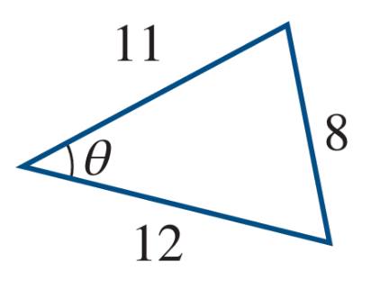
Calculate $θ$ to the nearest minute.
$$\cos{θ}=\frac{{11}^{2}+{12}^{2}-8^{2}}{2\left(11\right)\left(12\right)} \\ θ=\cos^{-1}\left(\frac{{11}^{2}+{12}^{2}-8^{2}}{2\left(11\right)\left(12\right)}\right) \\ θ=40°25'$$

- Guided Practice
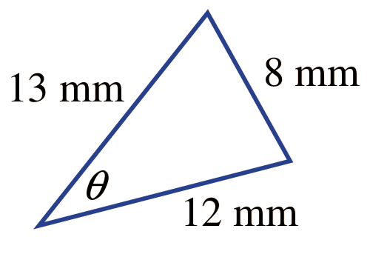  $$37° 3'$$ | 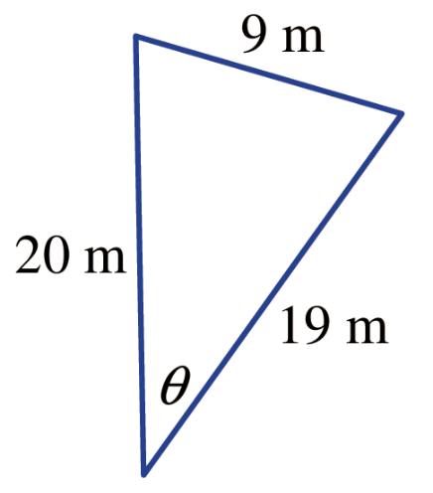  $$26° 32'$$

Foundation
- Solve for the unknown value in these equations. Answer to the nearest minute.
$$\cos{θ}=\frac{7^{2}+6^{2}-9^{2}}{2(7)(6)}$$  $$87°16'$$ | $$\cos{θ}=\frac{{21}^{2}+{30}^{2}-{18}^{2}}{2(21)(30)}$$  $$36°11'$$

- Find the value of the unknown in these triangles, correct to 2 decimal places.
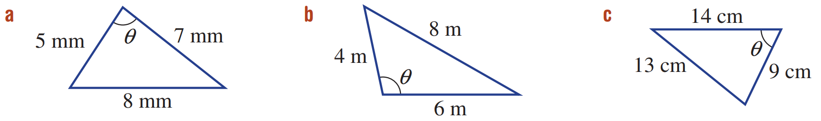  $$\cos{θ}=\frac{{\left( \right)}^{2}+{\left( \right)}^{2}-{\left( \right)}^{2}}{2\left( \right)( )}$$  $$θ=\cos^{-1}\left(\frac{{\left( \right)}^{2}+{\left( \right)}^{2}-{\left( \right)}^{2}}{2\left( \right)\left( \right)}\right)$$  $θ=$…………  81.79° | 104.48°

- Calculate the unknowns. Answer to 2 d.p. for lengths and the nearest degree for angles.
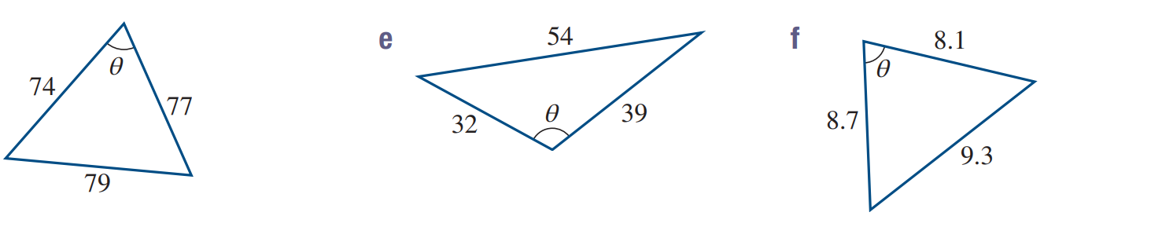  63° | 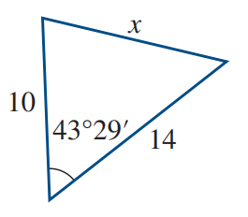  9.64 | 99°
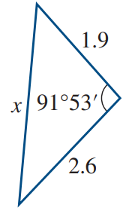  3.27 | 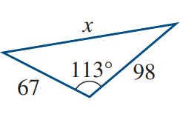  138.65 | 67°

Development
- Calculate the angle $θ$ using cosine rule. Answer to 2 d.p.
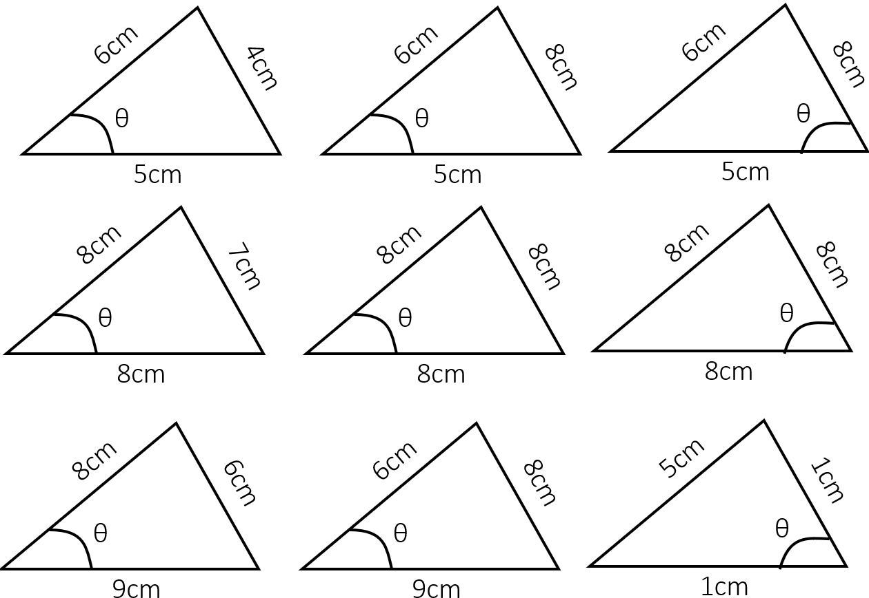  41.40° | 92.87° | 48.51°
60° | 60° | impossible triangle

- A triangle has side lengths 10 m, 7 m, and 13 m. Find the largest angle, to one decimal place.

Largest angle always opposite longest side
$$98.2°$$
- Three camp sites, A, B and C, are shown.
If campsite B is due north of camp site A, find the following, correct to 1 decimal place.
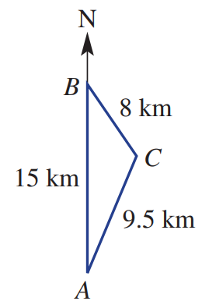
  - The bearing of campsite C from campsite B

145.9°
  - The bearing of campsite A from campsite C

208.2°
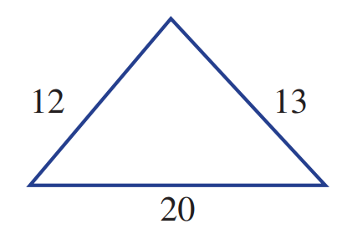
- Consider the triangle shown. Answer to the nearest degree.
  - Use cosine rule to find the size of the largest angle.

Largest angle opposite longest side: $106°$
  - Use sine rule to find the size of the smallest angle.

Smallest angle opposite shortest side: $35°$

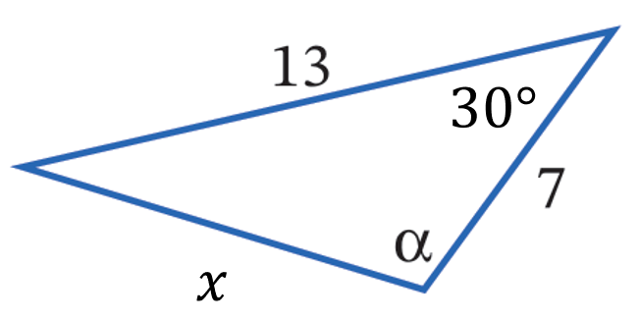
- Consider the triangle below.

  - Find $x$ using cosine rule to 4 d.p.

7.7707
  - Hence find $α$ to 2 d.p using cosine rule.

$$α=\cos^{-1}\left(\frac{{7.7707}^{2}+7^{2}-{13}^{2}}{2(7.7707)(7^{2})}\right)=123°14'$$
  - Use sine rule to find $α$ to check your answer.

$$α=\sin^{-1}\left(\frac{13\sin{30}}{7.77}\right)=56° 46’$$
Obtuse angle, so $180-56°{46}^{'}=123°14'$

Area of a Triangle using Trigonometry

- Review
- Calculate area of a triangle, given perpendicular dimensions
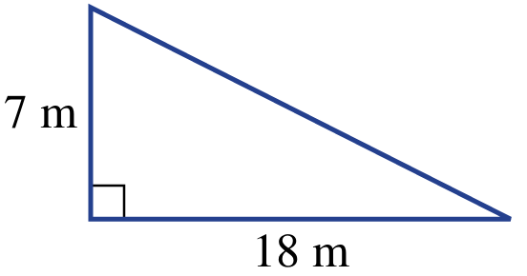 | 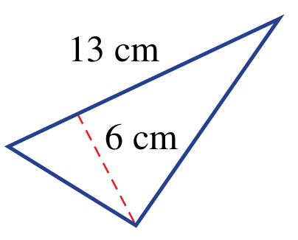

- Identify included angle.
- Is 50° the included angle between 11 and 7?  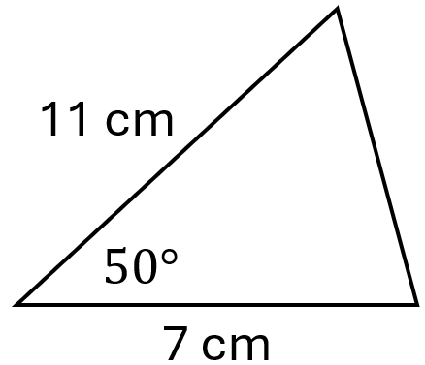 | - Is 120° the included angle between 8 and 14 cm?  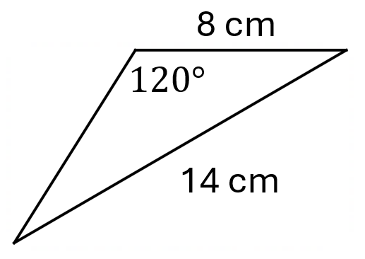
- What is the angle included between 12 cm and 15 cm?  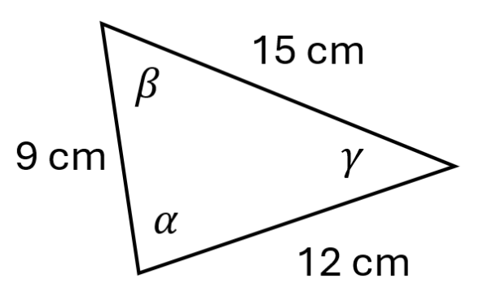 | - What two sides make the included angle of $50°$?  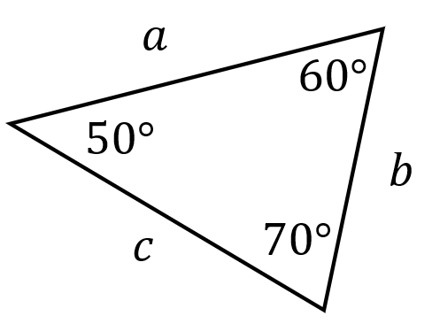

- SAS Area Rule
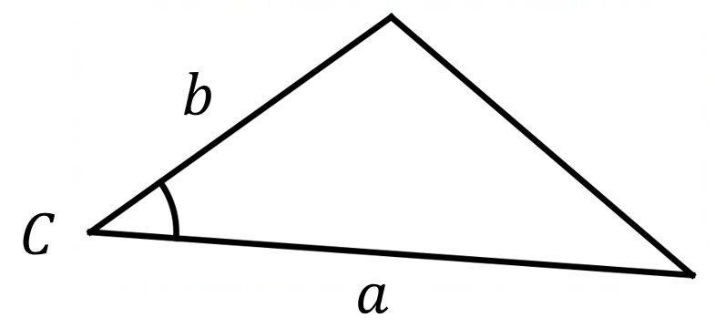
$$A=\frac{1}{2}ab\sin{C}$$

Where:
- $a$ and $b$ are two sides.
- $C$ is the included angle.

- Identify whether you can use SAS area rule to find area
✖  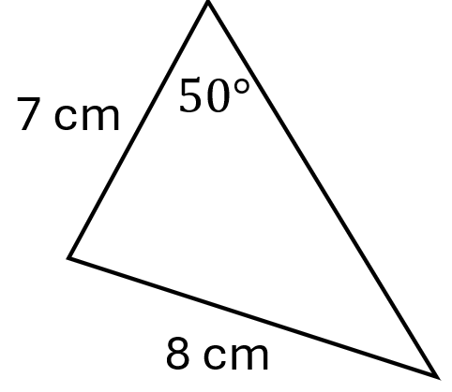 | ✔  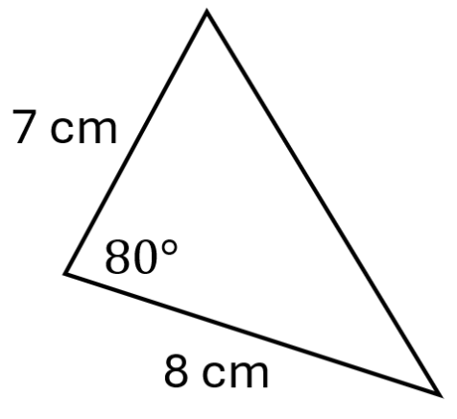 | ✔  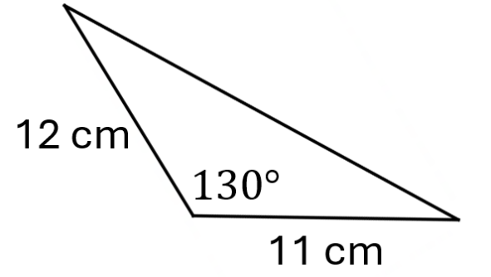 | ✖  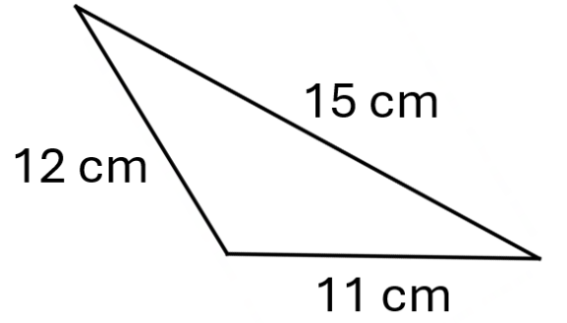
Identify whether you can use the SAS area rule to find the missing side.
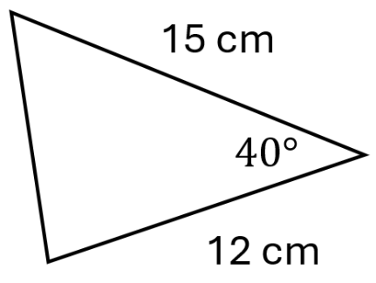 | 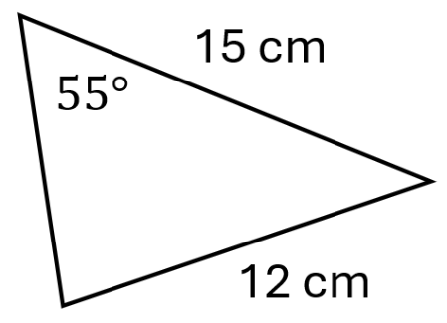 | 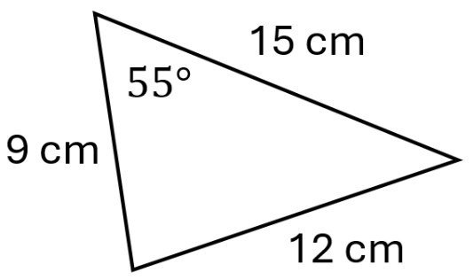 | 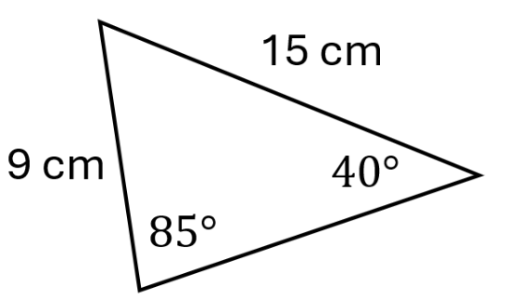

- SAS Area Rule
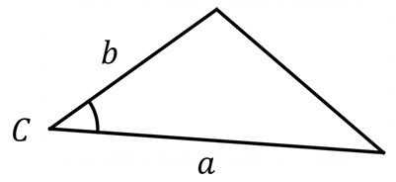

$$A=\frac{1}{2}ab\sin{C}$$

- Example Calculate area of a triangle using SAS area rule
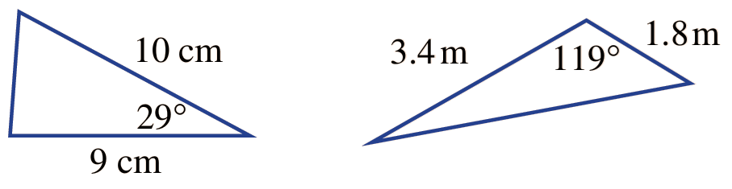
Find the area of this triangle, to 1 d.p.
$$A=\frac{1}{2}ab\sin{C} \\ =\frac{1}{2}\left(3.4\right)\left(1.8\right)\sin{119°} \\ ≈2.7 {km}^{2}$$

- Guided Practice
Find the area of these triangles, to 1 d.p.
21.8 cm² | 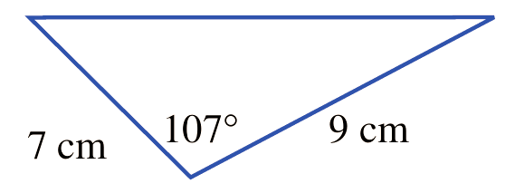  30.1 cm²
Find the side length, to 2 d.p., given the area.
- $A=70$ cm²  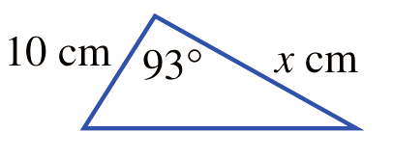  14.02 cm | - $A=37$ cm²  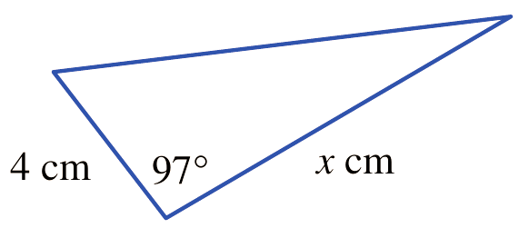  18.64 cm

Foundation
- Calculate the area of each triangle, correct to one decimal place.
$$A=\frac{1}{2}\left( \right)\left( \right)\sin{( )}$$  $=$ …………………  31.0 cm² | 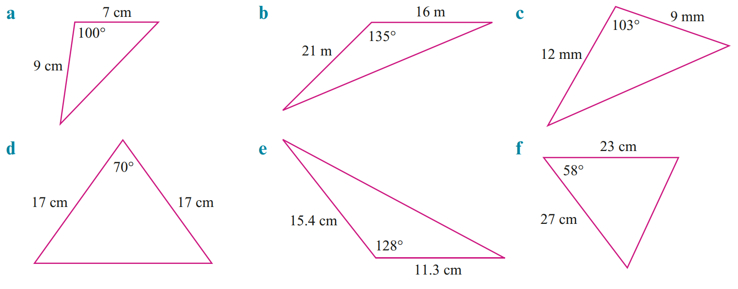  118.8 m² | 52.6 mm²
135.8 cm² | 68.6 cm² | 263.3 cm²

- Find the area of each triangle. Answer to 1 d.p.
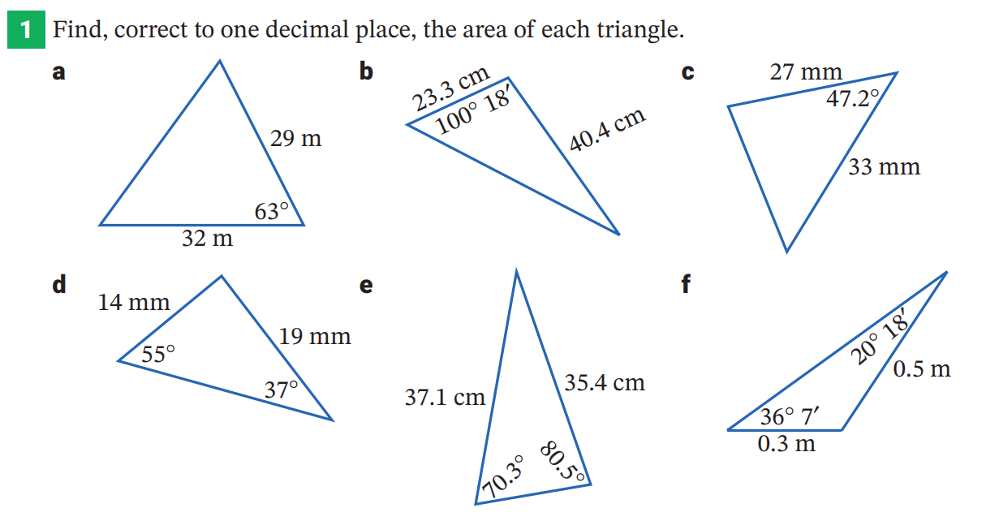  132.9 mm² | 320.4 cm² | 0.1 m²
- Calculate the value of $x$ correct to one decimal place.
x = 5.7 | x = 7.9 | 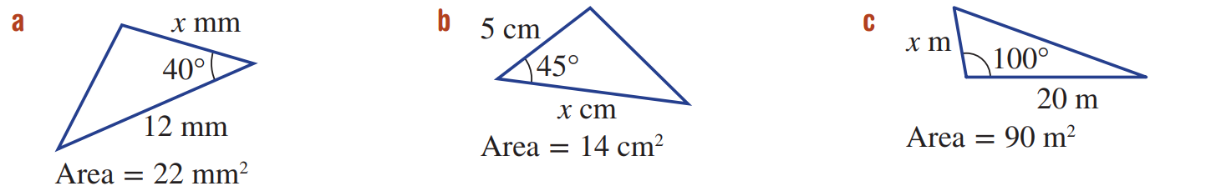  x = 9.1

Development
- Calculate the value of $θ$ given each triangle has area $72$ cm². Answer to the nearest minute.
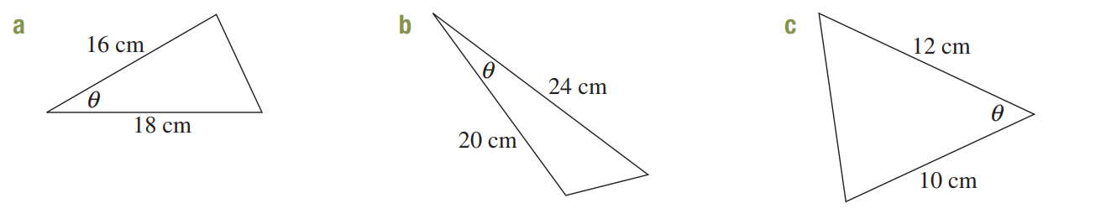  30° | 17°27′

- Find the area of these triangles.
204.9 sq units | 864.4 sq units | 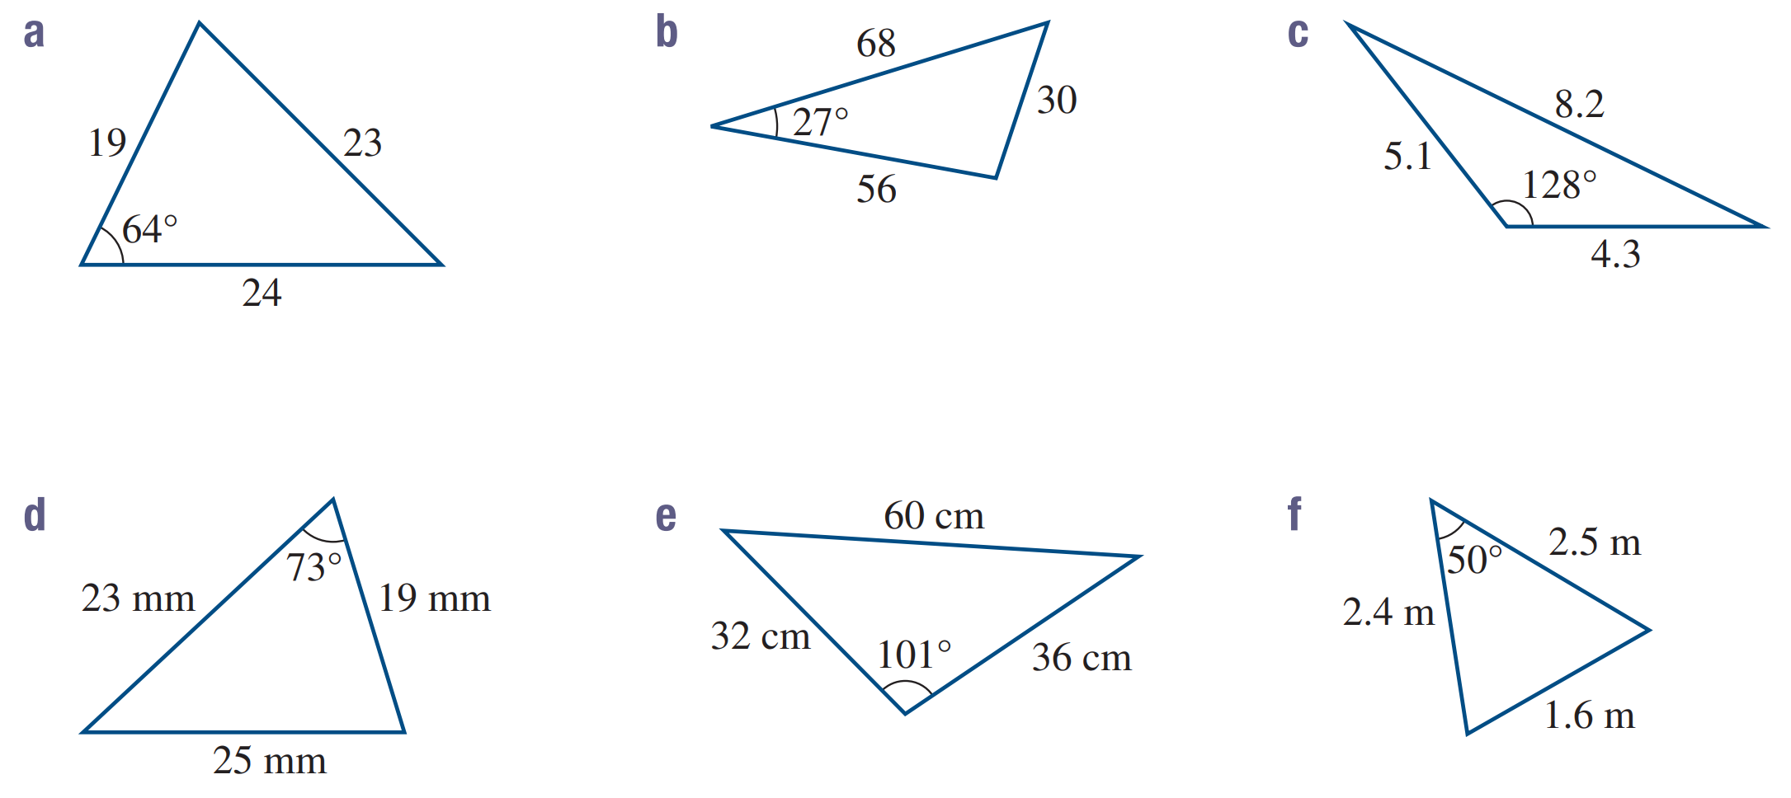  8.6 sq units
209.0 mm² | 565.4 cm² | 2.3 m²

- Find the area of these shapes.
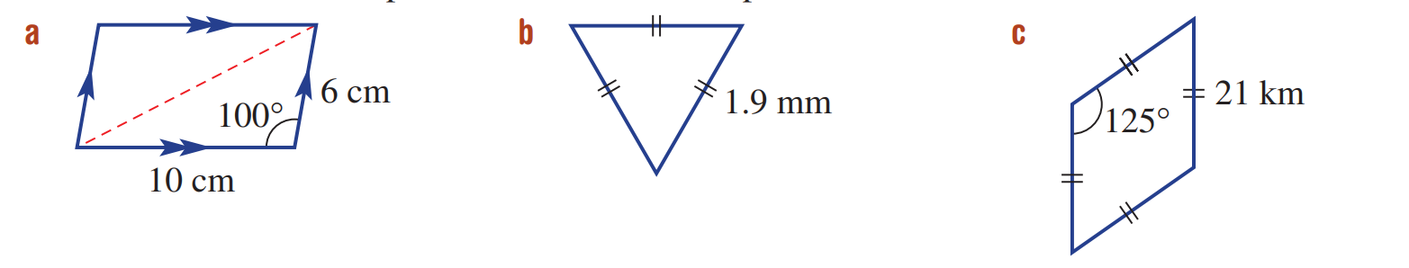  59.09 cm² | 1.56 mm² | 361.25 km²

Mastery
- Consider the triangle.
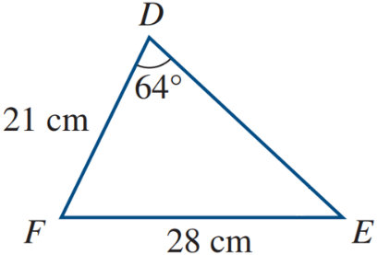
  - Explain why we cannot find the area of the triangle.
The angle is not in between two sides.
  - Using sine rule, find $∠DEF$ to the nearest degree.

$42°$
  - Hence calculate the area to the nearest square cm.

282 cm²
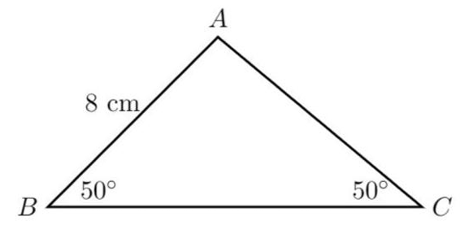
- Calculate the area of this triangle to 1 d.p.

31.5 cm²
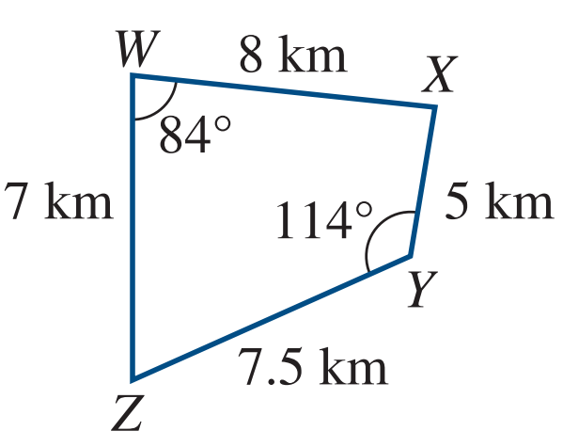
- A drawing of a farmer’s quadrilateral property is shown. By considering $ΔWXZ$ and $ΔXYZ$, calculate the area of the property in square km correct to one decimal place.

45.0 km²
- Calculate the area of these triangles. Answer in square cm to 1 d.p.
(Hint: Use sine rule and angle sum of a triangle)
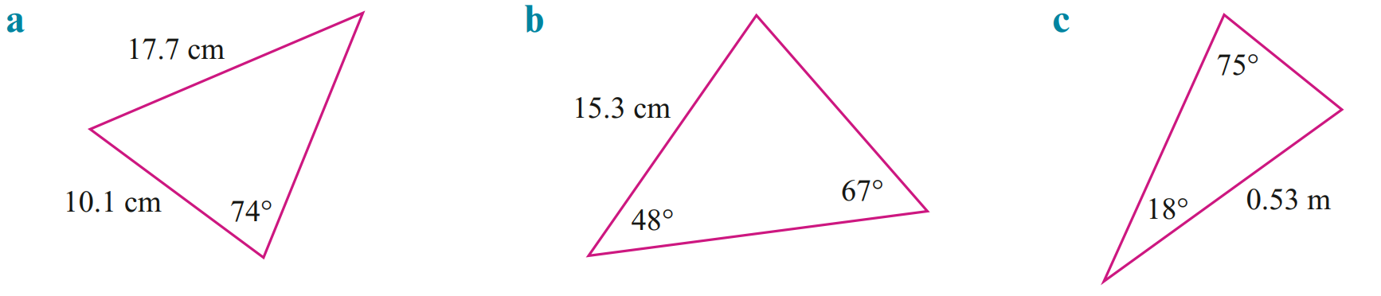  85.4 cm² | 85.6 cm² | 448.7 cm²
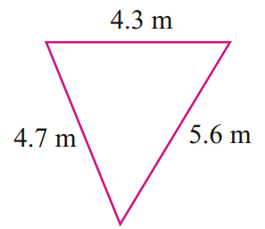
- Use cosine rule to find an angle, and hence calculate the area of this triangle to 1 d.p.

9.8 m²
- Proof of the SAS area formula
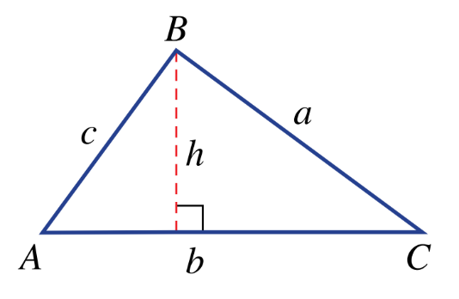
Consider the non-right-angled triangle shown.
The area of a triangle (from Year 8) is $A=$ $\frac{1}{2}$ $bh$
Write the equation for $\sin{C}$

$$\sin{C}=\frac{h}{a}$$
Make $h$ the subject of the equation you wrote above.

$$h=a\sin{C}$$
By combining $A=\frac{1}{2}bh$ and $h=a\sin{C}$, derive the side-angle-side formula for triangle area.

$$A=\frac{1}{2}b\left(a\sin{C}\right)$$
$$=\frac{1}{2}ab\sin{C}$$

Selecting an Appropriate Method

- Methods for Non-Right-Angled Triangles
For non-right-angled triangles, determine what is involved in the question:
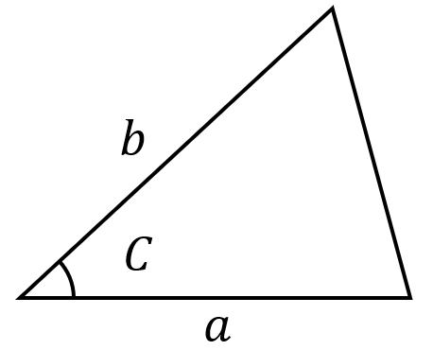  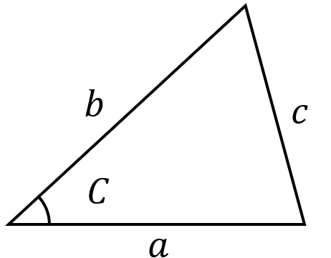  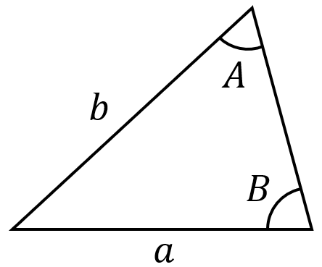  2 sides 2 angles  Sine Rule  $$\frac{\sin{A}}{a}=\frac{\sin{B}}{B}$$  $$\frac{a}{\sin{A}}=\frac{b}{\sin{B}}$$ | 3 sides 1 angle  Cosine Rule  $$c^{2}=a^{2}+b^{2}-2ab\cos{C} \\ \cos{C}=\frac{a^{2}+b^{2}-c^{2}}{2ab}$$ | Area  SAS Area Rule  $$A=\frac{1}{2}ab\sin{C}$$

- Identify which rule you would use to find the unknown
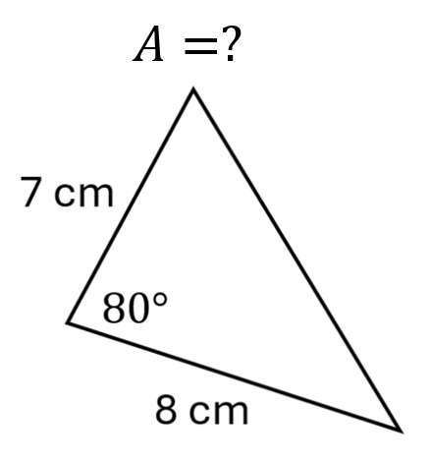

Foundation
- Decide whether cosine rule or sine rule should be used to find $x$. Do not solve for $x$.
cosine | 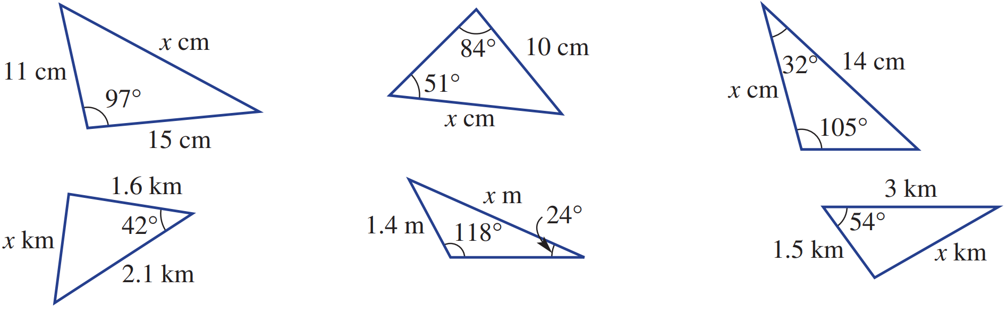  sine | sine
cosine | sine | cosine

- Use an appropriate method to find the unknown. Give lengths to 1 d.p. and angles to nearest degree.
28.3 | 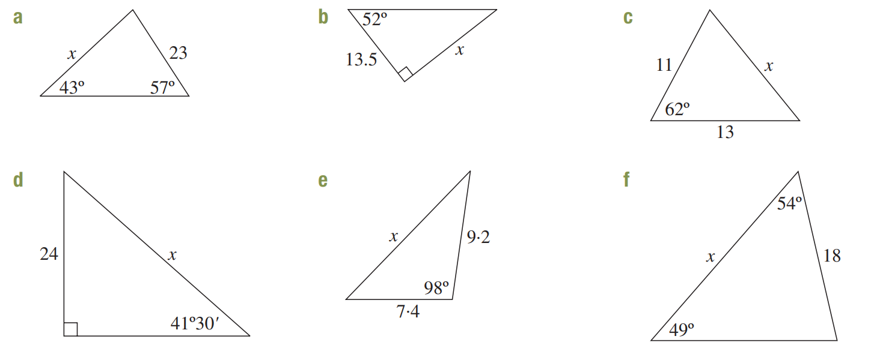  17.3 | 12.5
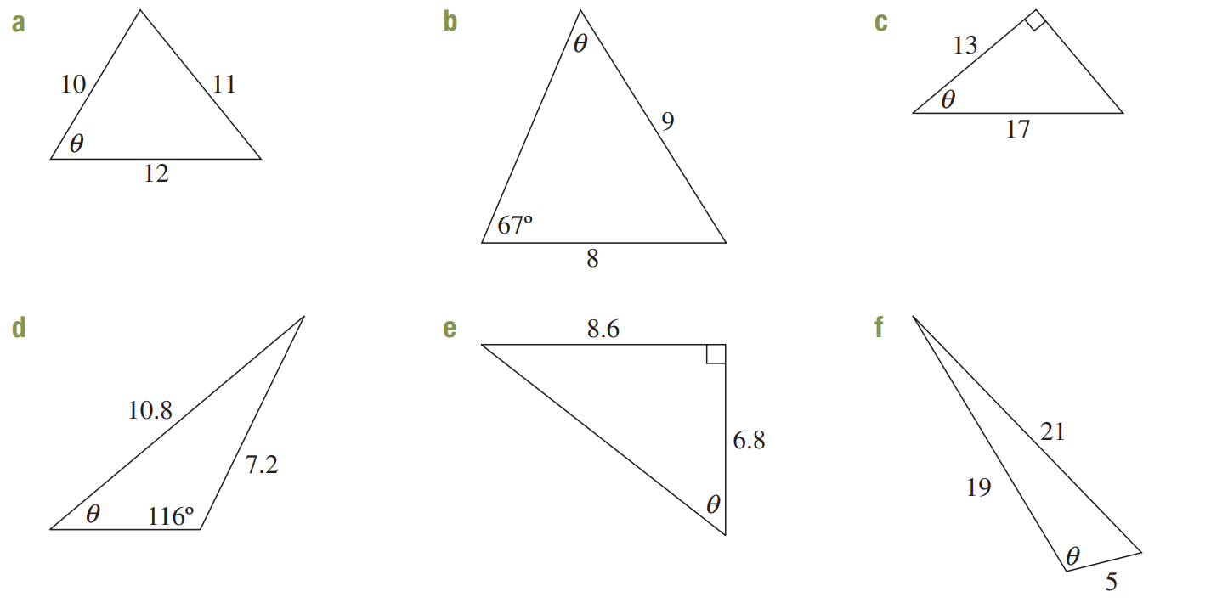  59° | 40° | 52°
37° | 12.6 | 23.2

Development

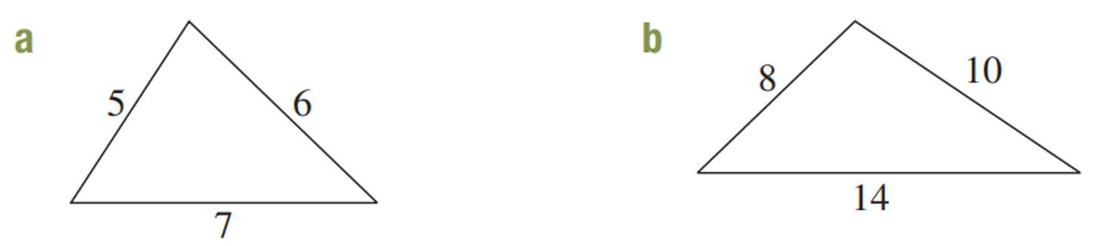  - Find the smallest angle,  correct to the nearest minute.  $$44°25'$$ | - Find the largest angle,  correct to the nearest minute.  $$101°32'$$

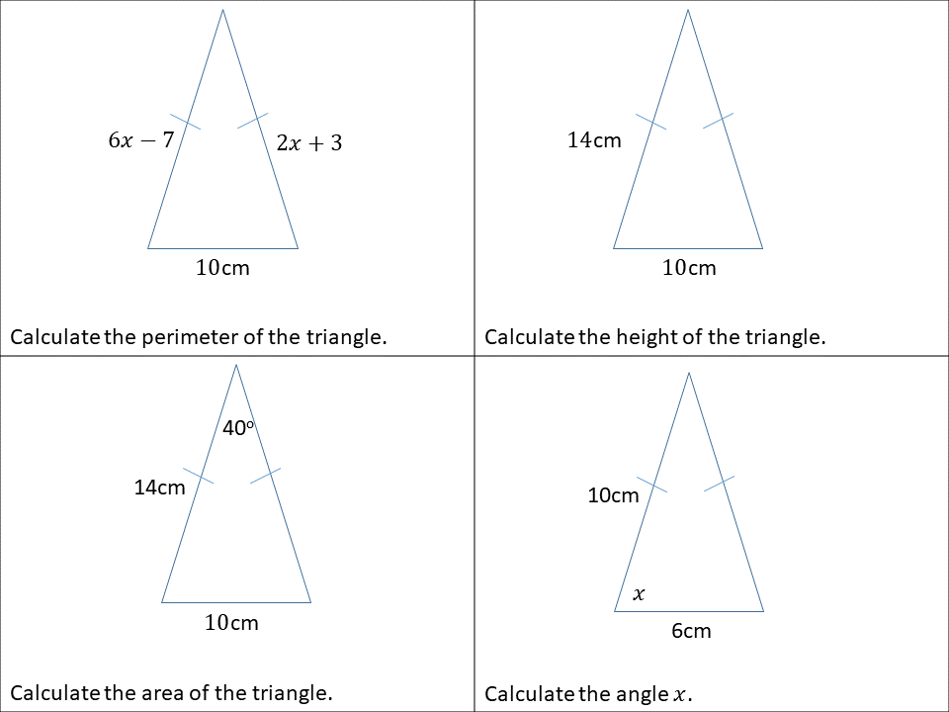  - Calculate the perimeter.  26 cm | - Calculate the height in exact form.  $\sqrt{171}$ cm
- Calculate the area to the nearest whole.  63 cm | - Calculate the angle to 1 d.p.  $$72.5°$$

- A triangle has sides of 21 m, 17 m, and 10 m.
Find the size of the largest angle, correct to the nearest degree.

$$99°$$
- Calculate the area of these triangles by using either sine rule or cosine rule to find the required information. Give your answer to 2 d.p.
35.03 cm² | 51.68 m² | 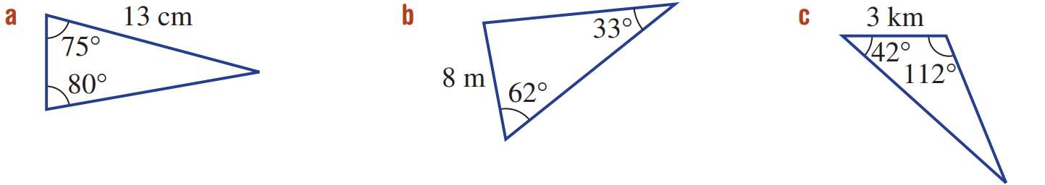  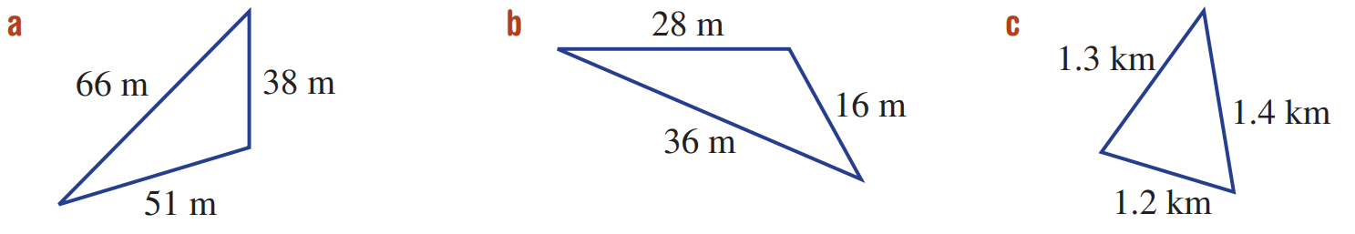  965.88 m²
214.66 m² | 6.37 km² | 0.72 km²

- The area of this isosceles triangle is $35$ cm². Find the length of the equal sides to 2 d.p.
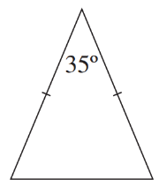

11.05 cm
- Calculate the area of these shapes. Round to 1 d.p.
17.3 m² | 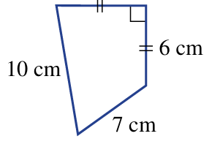  48 cm² | 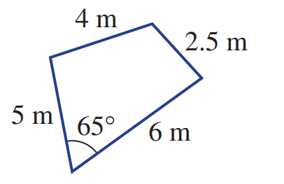  - (hint: use subtraction)  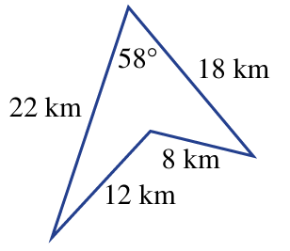  124.8 km²

Mastery

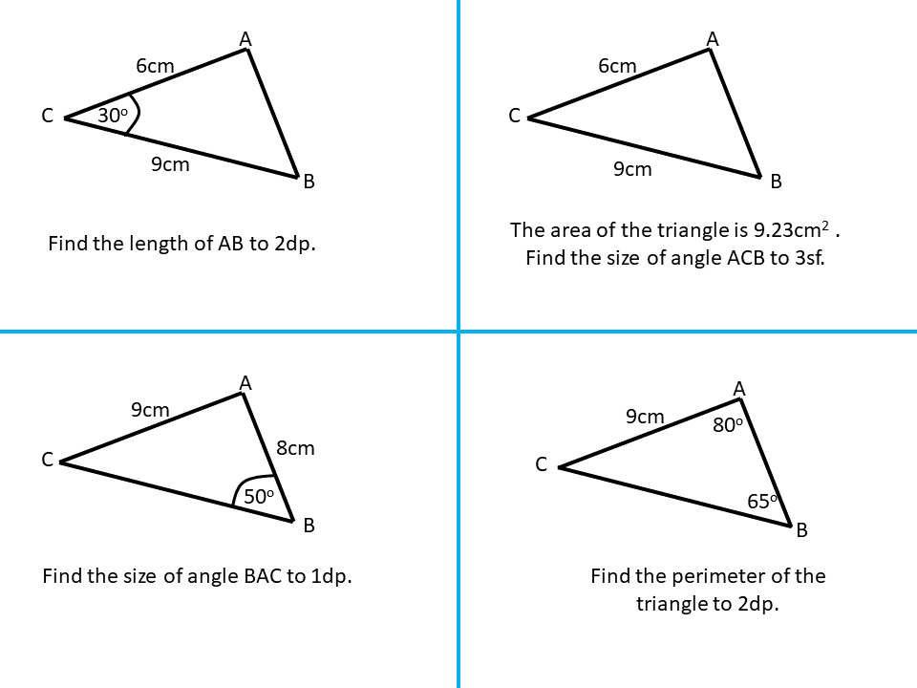  - Find the length of AB to 2 d.p.  4.84 cm | - The area of the triangle is 9.23 cm².  Find the size of $∠ACB$ to the nearest degree.  $$20°$$
- Find the size of angle $∠BAC$ to 1 d.p.  87.1° | - Find the perimeter of the triangle to  2 d.p.  24.48 cm

- Find the unknown value, round lengths to 2 d.p. and angles to the nearest degree.
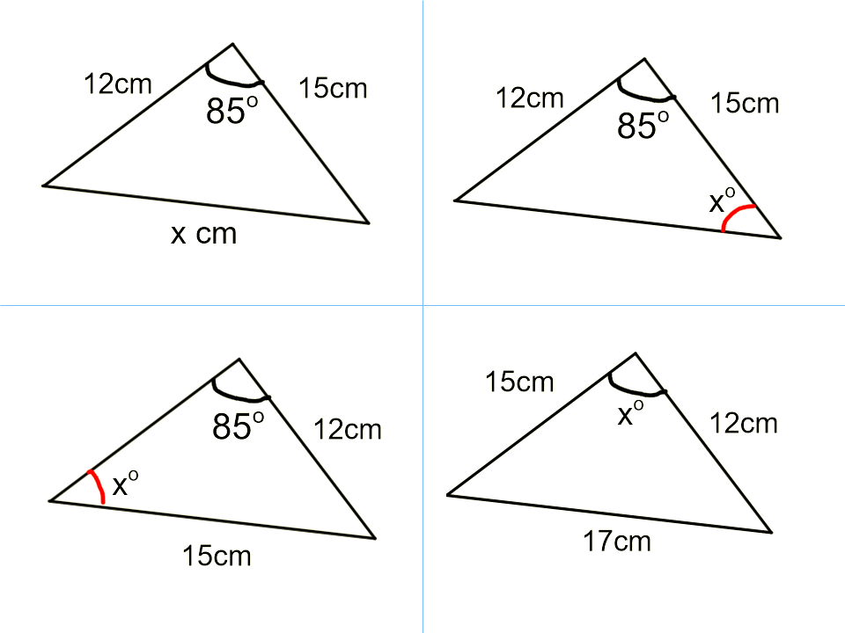  18.37 cm | 77°
53° | 41°
- Determine the value of the variables to one d.p. for lengths and the nearest minute for angles.
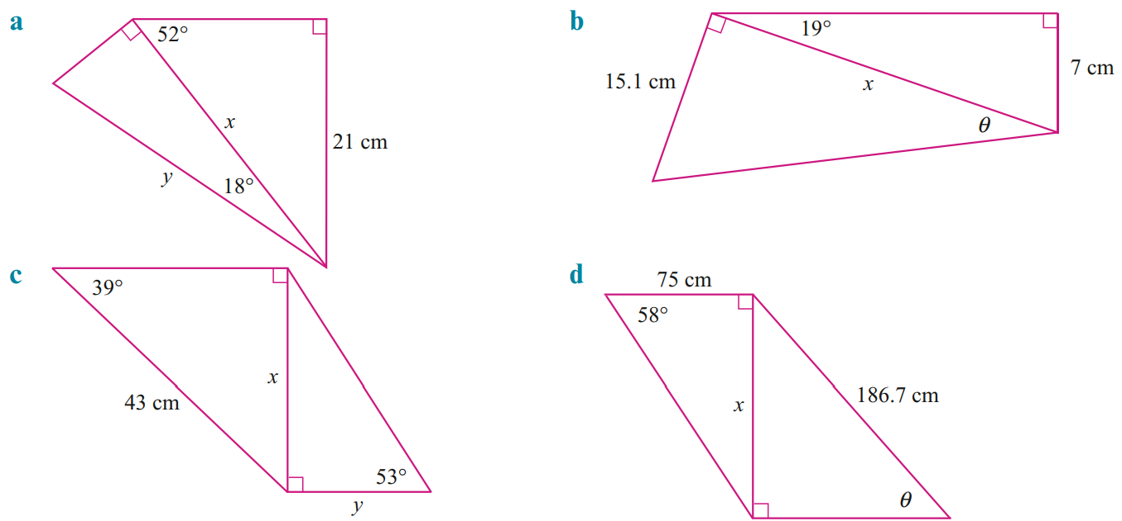  x = 26.6 cm, y = 28.0 cm | x = 21.5 cm, θ = 35°5′
x = 27.1 cm, y = 20.4 cm | x = 120.0 cm, θ = 40°0′

- Calculate the area of each shape correct to one decimal place. All measurements are in metres.
- Equilateral triangle  97.4 m² | - Parallelogram  463.6 m² | 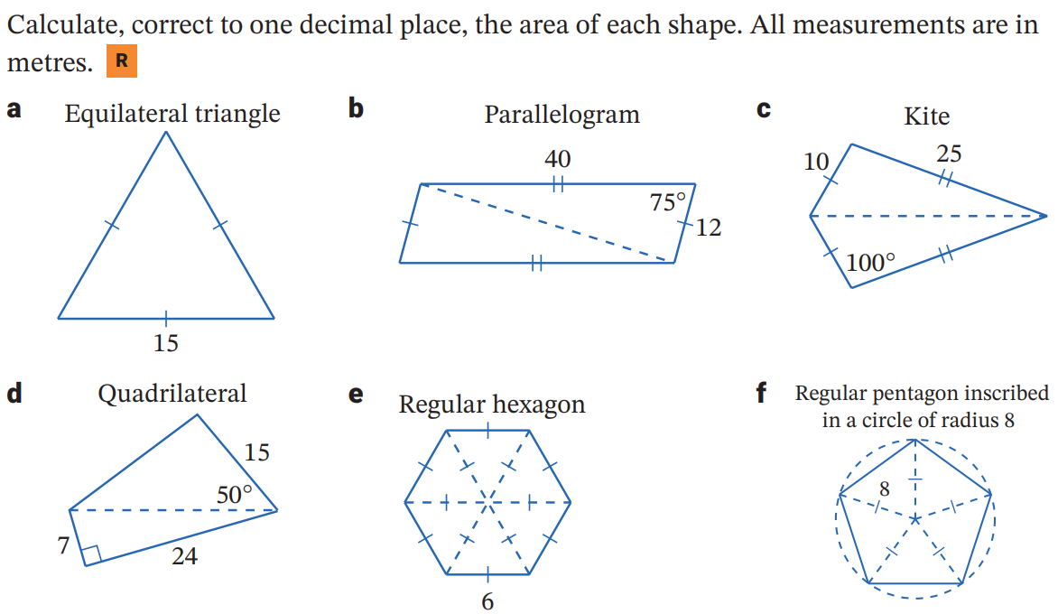  - Kite  246.2 m²
- Quadrilateral  227.6 m² | - Regular hexagon  93.5 m² | - Regular pentagon inscribed in a circle  152.2 m²

Mixed Multistep Trigonometry Problems

Foundation
- Andrew plans to build a triangular flower bed in the lower part of a circular garden.
The length of TS is 24m, ∠TSR is 45°and ∠RTS is 40°.
  - What is the size of ∠SRT?
  - Find the length of TR. Answer correct to the nearest metre.
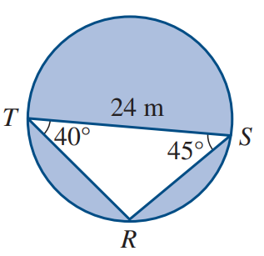

a) 95° b) 17 m
- Two ladders are the same distance up the wall.
The shorter ladder is 4.9m long and makes an angle of 48° with the ground.
The longer ladder is 6.7m long.
  - How far up the wall do the ladders reach?
Answer correct to one decimal place.
  - What is the angle, to the nearest degree, that the longer ladder makes with the ground?
  - Find the distance between the ladders on the ground. Answer to one decimal place.
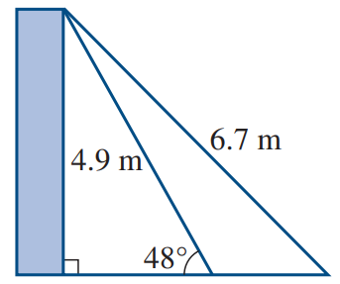

a) 3.6 m, b) 33° c) 2.3 m
- $O$ is the centre of a circle of radius 20 cm. Calculate, correct to one decimal place, the area of:
  - Sector $OPQ$.
  - Triangle $OPQ$.
  - The shaded segment.
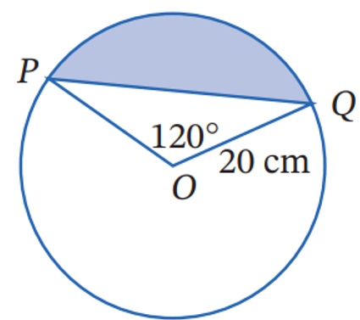

a) 418.9 cm² b) 173.2 cm² c) 245.7 cm²
- A triangular prism has base edge of 8 cm, 10 cm, and 15 cm, and a height of 20 cm.
  - Calculate the size of $∠PRQ$, correct to the nearest degree.
  - Find the area of $ΔPQR$, correct to the nearest cm².
  - Find the volume of the prism.
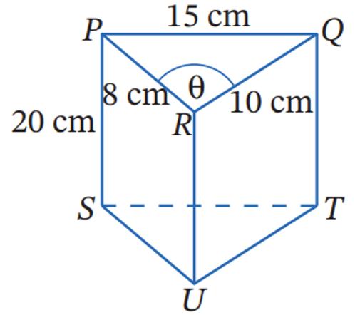

a) 112° b) 37 cm² c) 740 cm³
- The area of an equilateral triangle is 600 cm².
Calculate the perimeter of the triangle, correct to 1 d.p.

111.7 cm
- The angles of elevation of a building measured from 2 positions 80 m apart of $32°$ and $55°$.
  - Explain why $∠ATB=23°$
  - Find, correct to 2 decimal places, the length of $BT$.
  - Hence find the height $h$ of the building, correct to the nearest metre.
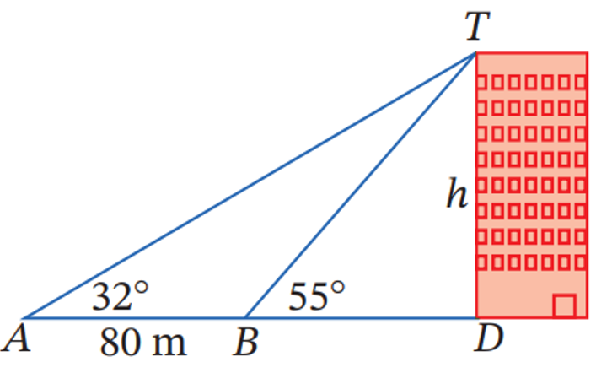

a) ∠ ATB = 55° − 32° (exterior angle theorem), other answers possible
b) 108.50 m
c) 89 m
- A soccer goal is 8 m wide. A player shoots for goal (along the ground) when 20 m from one post and 15 m from the other post. Within what angle (correct to the nearest 0.1 degree) must the shot be made for the player to have a chance of scoring a goal?
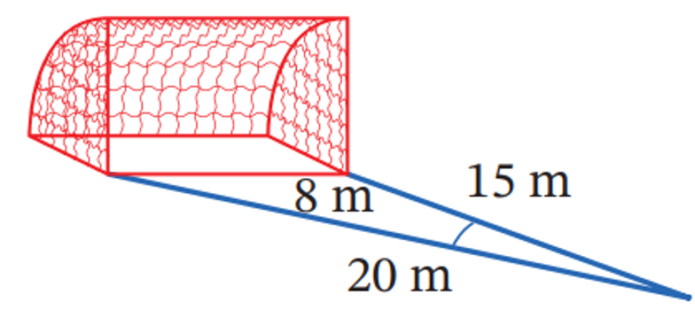

20.8°

Development
- Melissa is standing at $A$ on a path that leads to the base $B$ of a vertical flagpole.
The path is inclined at $12°$ to the horizontal, and the angle of elevation of the top $T$ of the flagpole from $A$ is $34°$.
  - Explain why $∠TAB=22°$ and $∠ABT=102°$
  - Given that $AB=20$m, find the height of the flagpole, correct to the nearest metre.
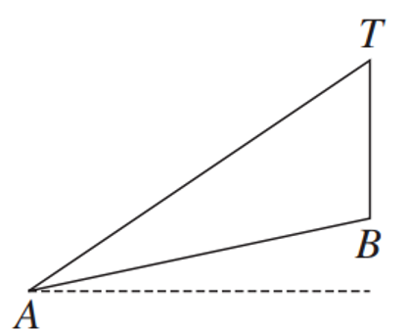

9 metres
- A parallelogram $ABCD$ has sides $AB=DC=47$mm and $AD=BC=29$ mm.
The longer diagonal $BD$ is 60 mm. Find the following, round your answer to the nearest minute.
  - Use the cosine rule to find the size of $∠BCD$.
  - Use co-interior angles to find the size of $∠ABC$.
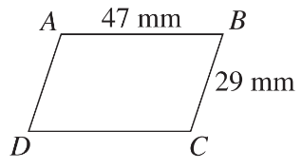

a) 101°38’
b) 78°22’
- A survey of a park is shown in the diagram.
A path is proposed from B to D and a fence is required from B to C to D.
  - What is the length of the path? Answer correct to the nearest metre.
  - Calculate the required length of fencing. Answer correct to the nearest metre.
  - What is the area of the park? Answer correct to the nearest square metre.
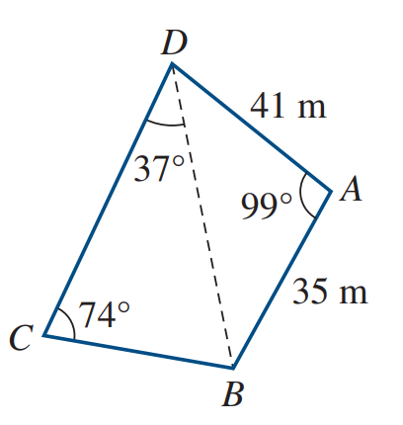

a) 58 m
b) 93 m
c) 1689 m²

Mastery
- 2016 HSC Standard 2 Band 4
A school playground consists of part of a circle and a rectangle as shown in the diagram.
What is the area of the whole playground, correct to the nearest square metre?
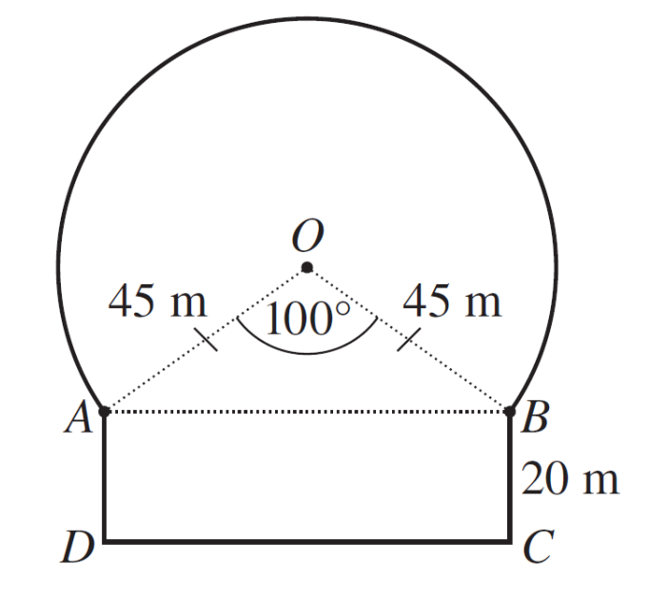

6971 m²
- 2022 HSC Standard 2 Band 5
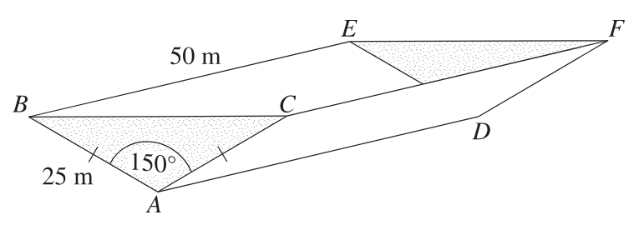
A dam is in the shape of a triangular prism which is 50 m long, as shown.
Both ends of the dam, ABC and DEF, are isosceles triangles with equal sides of 25 metres.
The included angles $∠BAC$ and $∠EDF$ are each $150°$
Calculate the number of litres of water the dam will hold when full.

7 812 500 L

- 2023 HSC Standard 2 Band 5
The diagram shows a shape APQBCD. The shape consists of a rectangle ABCD with an arc PQ on side AB and with side lengths BC = 3.6 m and CD = 8.0 m.
The arc PQ is an arc of a circle with centre O and radius 2.1 m and ∠POQ = 110$°$
What is the perimeter of the shape APQBCD?
Give your answer correct to one decimal place.
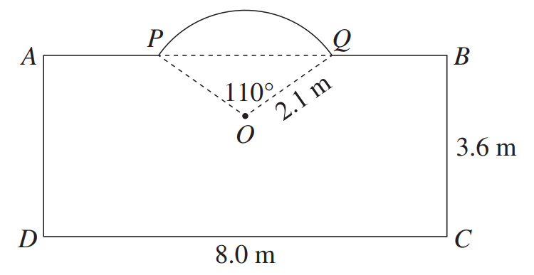

23.8 m
- Two towers AB and PQ stand on level ground. The angles of elevation of the top of the taller tower from the top and bottom of the shorter tower are 5° and 20° respectively.
The height of the taller tower is 70 metres.
  - Explain why $∠APJ = 15°$.
  - Show that $AB =$ $\frac{BP\sin{15°}}{\sin{95°}}$
  - Show that $BP =$ $\frac{70}{\sin{20°}}$
  - Hence find the height of the shorter tower, correct to the nearest metre.
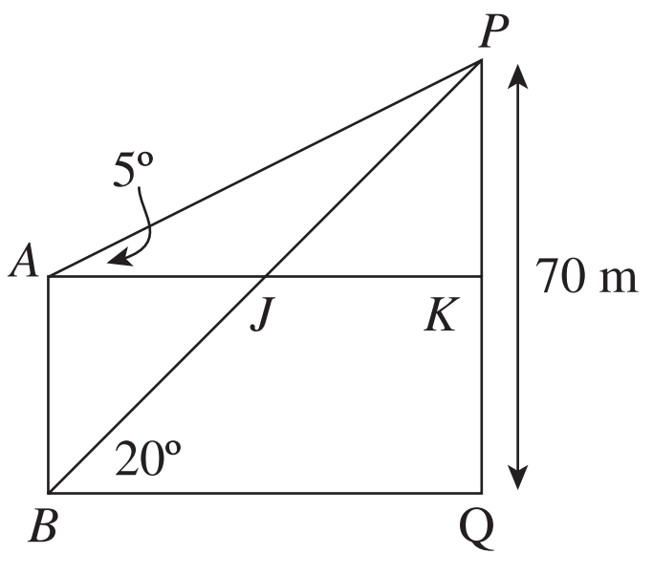

53 metres
- Recall that the sum (S) of the interior angles of a polygon with $n$ sides is given by
$S = 180(n - 2)$.
Calculate the area of the pentagon. Answer to 1 d.p.
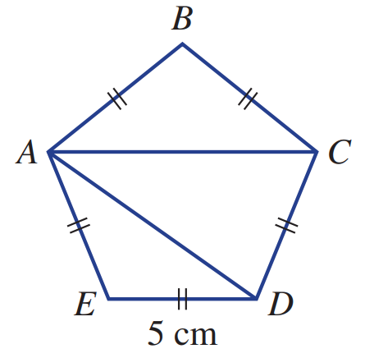

$$ΔAED=ΔABC=11.89 {cm}^{2}$$
$$ΔADC=19.24 {cm}^{2}$$
43.0 cm²
- Two towers $AB$ and $PQ$ stand on level ground. Tower $AB$ is 12 metres taller than tower $PQ$.
From $A$, the angles of depression of $P$ and $Q$ are 28° and 64° respectively.
  - Use ΔAKP to show that $KP = BQ =12\tan{62°}$.
  - Use ΔABQ to show that $AB =12\tan{62°}\tan{64°}$.
  - Hence find the height of the shorter tower, correct to the nearest metre.
  - Solve the problem again by using $ΔAKP$ to find $AP$, and then using the sine rule in $ΔAPQ$.
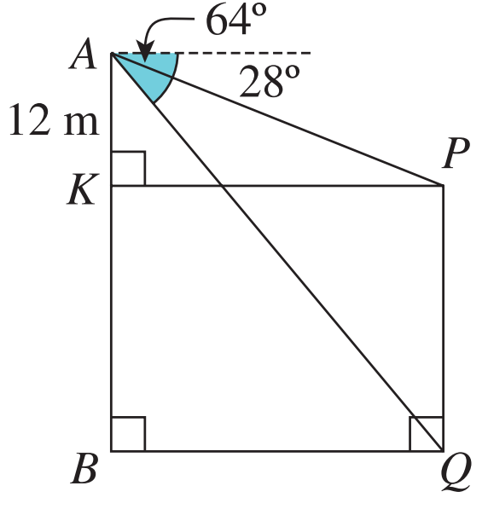

Shorter tower is 34 metres
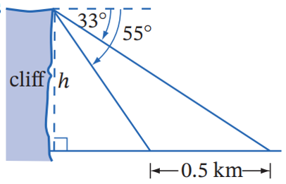
- From the top of the cliff, the angles of depression of 2 boats at sea that are 0.5 km apart are $55°$ and $33°$. Show that the height of the cliff $h=\frac{0.5\sin{33°}\sin{55°}}{\sin{22°}}$
Let the distance of the closer boat to the observer be $x$.
$$\sin{55°}=\frac{h}{x}, x=\frac{h}{\sin{55°}}$$
Using sine rule,
$$\frac{0.5}{\sin{22°}}=\frac{x}{\sin{33°}}$$
$$\frac{0.5}{\sin{22°}}=\frac{\left(\frac{h}{\sin{55°}}\right)}{\sin{33°}}$$
$$\frac{0.5}{\sin{22°}}=\frac{h}{\sin{55°}\sin{33°}}$$
$$∴h=\frac{0.5\sin{33°}\sin{55°}}{\sin{22°}}$$

- The diagram shows a parallelogram.
  - Explain why $ΔADP$ is equilateral, and hence find $AP$.
  - Use the cosine rule in $ΔBCP$ to find $BP$ in exact form.
  - Let $∠APB=x$. Show that $\cos{x}=-$ $\frac{\sqrt{7}}{14}$
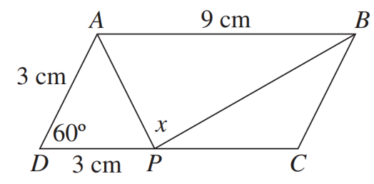

a) isosceles triangle, so $∠ADP=∠DPA$ and $∠ADP+∠DPA=120$.
$∴∠ADP=∠DPA=60°$
Equilateral as all angles 60
$∴AP=3$ cm
b) $3\sqrt{7}$ cm
c) $\cos{x}=$ $\frac{3^{2}+{\left(3\sqrt{7}\right)}^{2}-9^{2}}{2\left(3\right)\left(3\sqrt{7}\right)}$ $=$ $\frac{-9}{18\sqrt{7}}$ $=$ $\frac{-9\sqrt{7}}{126}$ $=$ $\frac{-\sqrt{7}}{14}$

Mixed Trigonometry Problems involving Bearings

Foundation
- Refer to the diagram to answer the following questions.
  - Calculate $∠PQR$ and hence $∠RQO$ to the nearest degree.
  - Find the length $OR$, correct to one decimal place.
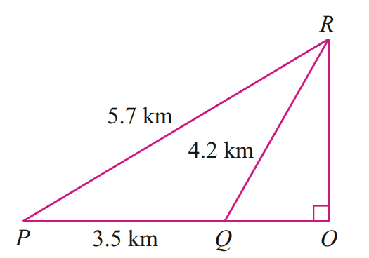
  - If $OR$is North, find the true bearing of $Q$ from $R$

a) $∠PQR=$ 95°,$∠RQO=$ 85°
b) 4.2 km
c) 185°
- XYZ represents a triangular area of land.
The bearing of X from Y is 041° and the bearing of Z from Y is 305°.
The distance XY is 27m and the distance YZ is 37 m.
  - What is the size of angle XYZ? Answer correct to the nearest degree.
  - Calculate the area to the nearest square metre.
  - What is the length of the boundary XZ, to the nearest metre?
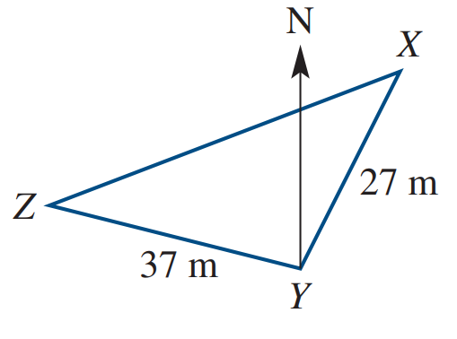

a) 96°
b) 497 m²
c) 48 m
- The diagram shows information about the locations of towns P, Q and R.
Amber takes 2 hours and 30 minutes to walk directly from Town P to Town Q.
  - What is Amber’s walking speed, correct to the nearest km/h?
  - What is the distance from P to R? Answer correct to the nearest kilometre.
  - How long would it take Amber to walk from P to R? Answer to the nearest minute.
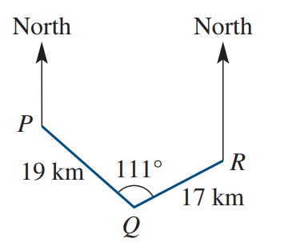

a) 8 km/h
b) 30 km
c) 3 h 45 min
- M is 50km north of O. The bearing of N from M is 108° and from O it is 061°.
Answer the following questions to the nearest kilometre.
  - What is the distance between M and N?
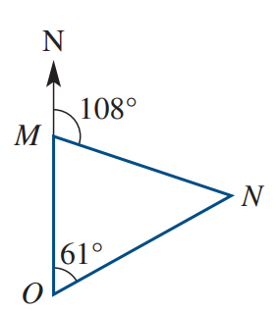
  - What is the distance between N and O?

a) 60 km
b) 65 km
- A ship is located at B and two radar stations 75 km apart are located at A and C.
The bearing of the ship from one radar station is 038° and from the other radar station it is 306°.
C is due east of A.
  - How far is the ship from the radar station at A, to the nearest kilometre?
  - How far is the ship from the radar station at C, to the nearest kilometre?
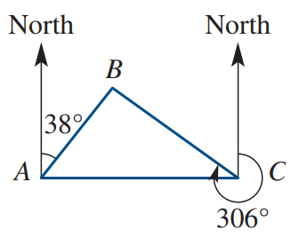

a) 44 km
b) 59 km
- A salesman drove from town $A$ to town $B$, then to town $C$, then finally directly home to town $A$.
Town B is 67 km north of town $A$, and the bearings of town $C$ from towns $A$ and $B$ and $039°T$ and $063°T$ respectively. Find how far the salesman drove, correct to the nearest kilometre.
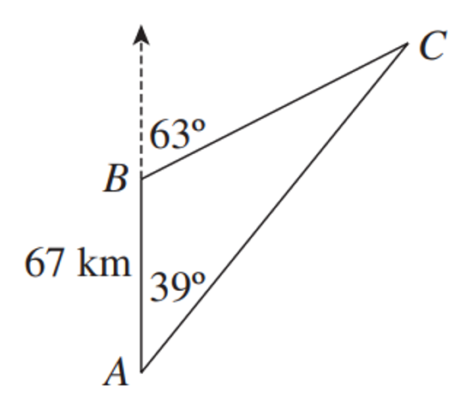

317 km

Development
- In the diagram to the right, ship $A$ is 120 nautical mules from lighthouse $L$ on a bearing of $072°T$, while ship $B$ is 180 nautical miles from $L$ on a bearing of $136°T$.
Calculate the distance between the two ships, correct to the nearest nautical mile.
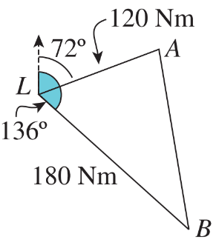

167 nautical miles
- A ship sails 53 nautical miles from $P$ to $Q$ on a bearing of $026°T$.
It then sails 78 nautical miles due east from $Q$ to $R$.
  - Explain why $∠PQR = 116°$
  - How far apart are $P$ and $R$, correct to the nearest nautical mile?
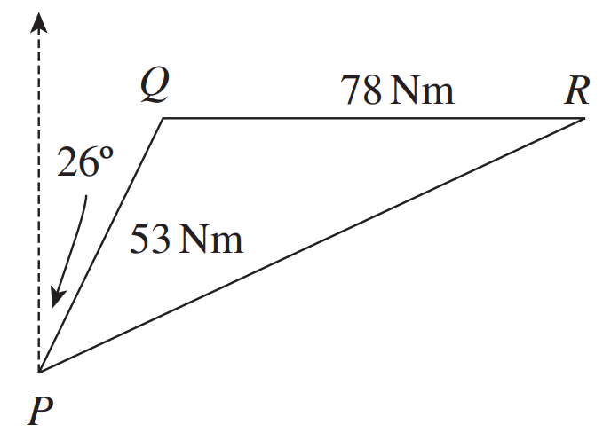

a) draw a north-south line at Q, $∠PQR=90+26=116$ due to alternate angles
b) 112 nautical miles
- A yacht sails from $X$ to $Y$ on a bearing of 130$°$ for 4.2 km.
It then turns and travels to $Z$ on a bearing of $025°$ for 2.9 km.
  - Label the diagram.
  - Explain why $∠XYZ=75°$
  - Calculate the distance $XZ$, correct to 1 d.p.
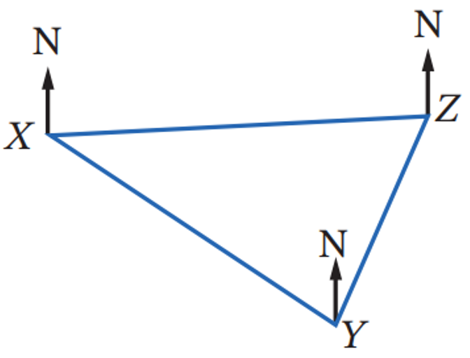

b) ∠ XYN = 180° – 130° = 50° (co-interior angles on parallel lines)
c) 4.4 km

Mastery
- Yorker (Y) is 134 km due east of Vendor (V).
Xena (X) is on a bearing of 232° from Yorker and is also 85 km from Vendor.
∠VXY is an obtuse angle. Find the bearing of Xena from Vendor.
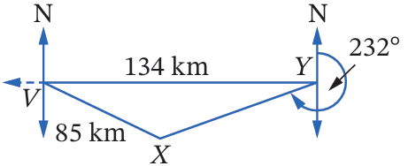

128°
- A ship sails 85 km from A to B on a bearing of 060° T.
It then turns and sails 120 km to C on a bearing of 130° T.
  - Find the size of ∠ABC.
  - How far is the ship from its starting point?
  - Calculate ∠BAC, to the nearest minute.
  - What is the bearing of the ship from its starting point to the nearest minute?
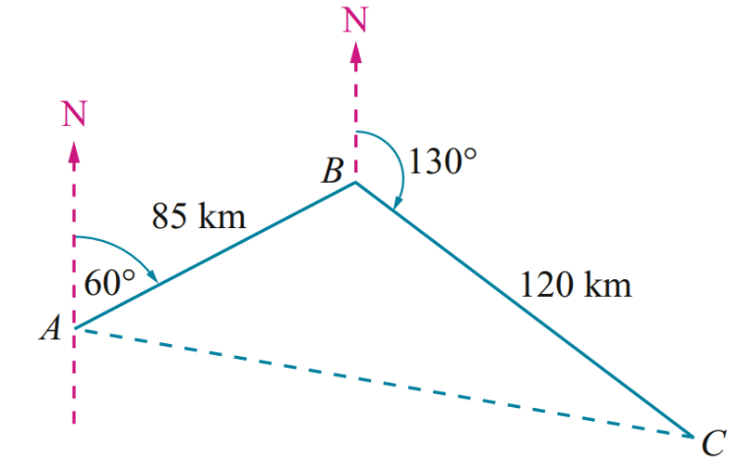

a) 110°
b) 169 km
c) 41° 49’
d) 101° 49’ T
- Consider the diagram.
  - Show that the distance $BX$ is 17.9 km.
  - Show that the distance from $B$ to $X$ via $A$ is 22.2 km.
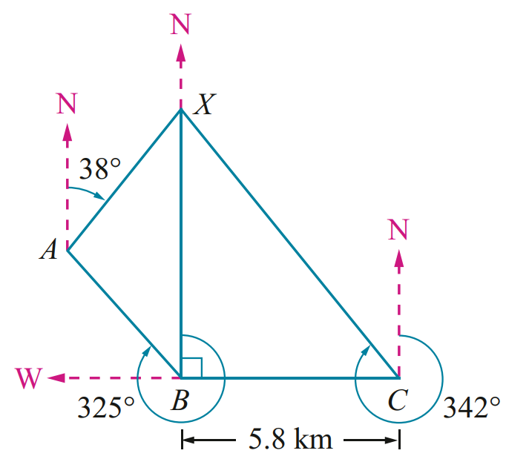

- 2023 HSC Standard 2 Band 5
The diagram shows the location of three places X, Y and C.
Y is on a bearing of 120° and 15 km from X.
C is 40 km from X and lies due west of Y.
P lies on the line joining C and Y and is due south of X.
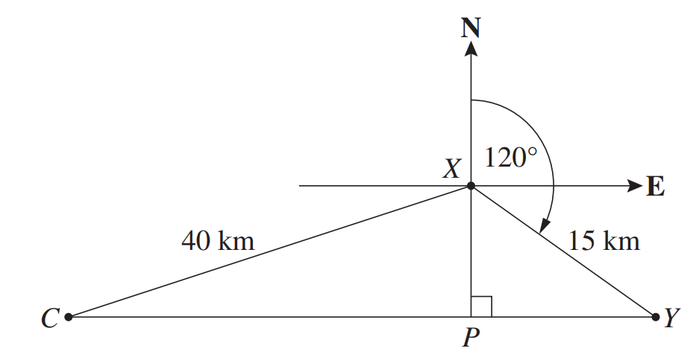

  - Find the distance from X to P.

7.5 km
  - What is the bearing of C from X, to the nearest degree?

259°
- A ship sails 50 km from port $A$ to port $B$ on a bearing of $063°T$,
then sails 130 km from port B to port C on a bearing of $296°T$.
  - Show that $∠ABC = 53°$
  - Find, correct to the nearest km the distance of port A from port $C$.
  - Find $∠ACB$, and hence find the bearing of port $A$ from port $C$,
correct to the nearest degree.
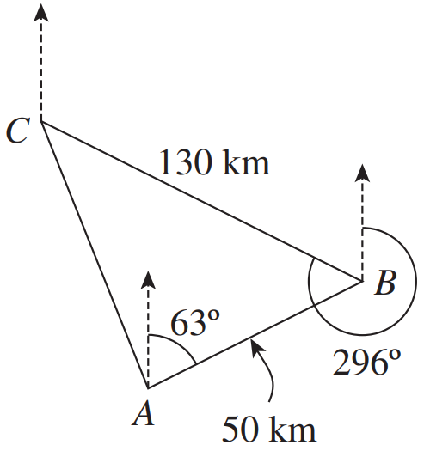

a) extend north line at B, $∠ABC=296-63-180=53°$
b) 108 km
c) $∠ACD≈22°,$bearing $≈138°$
- A motorist drove 70km from town A to town B on a bearing of 056°T,
and then drove 90km from town B to town C on a bearing of 146°T.
  - Explain why $∠ABC=90°$
  - How far apart are the towns A and C,
correct to the nearest kilometre?
  - Find ∠BAC, and hence find the bearing of town C from town A, to the nearest degree.
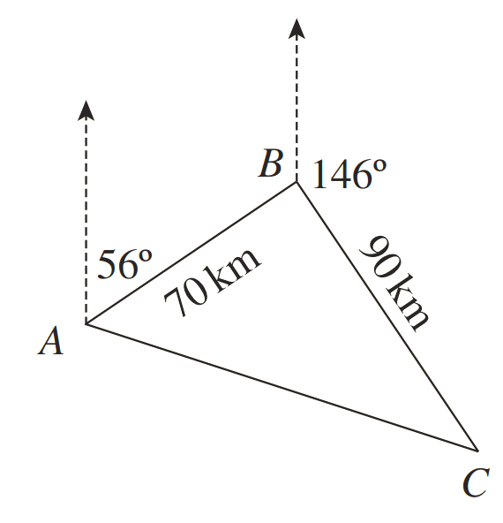

a) angle co-interior to 56° is 124°.
$∠ABC=360-124-146=90°$
b) 114 km
c) 108°
- 2022 HSC Standard 2 Band 5
The diagram shows an aeroplane that was flying towards an airport at $A$ on a bearing of $135°$T.
When it was at point $O$, 20 km away from the airport at $A$, the flight course was changed.
The aeroplane landed at an airport at $B$ directly south of $O$. The distance from $O$ to $B$ is 50 km.
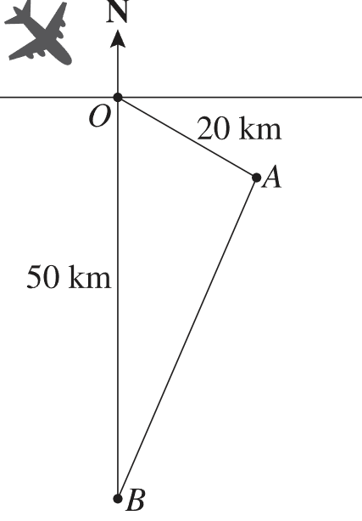
  - Show that the distance between airport $A$ and airport $B$ is 38.5 km, correct to 1 d.p.

38.5 km
  - Find $∠OBA$ to the nearest degree.

22°
  - What is the bearing of the airport at $B$ from the airport at $A$?

202°

- 2024 HSC Advanced Band 4
A vertical tower TC is 40 metres high. The point A is due east of the base of the tower C.
The angle of elevation to the top T of the tower from A is 35°.
A second point B is on a different bearing from the tower as shown.
The angle of elevation to the top of the tower from B is 30°.
The points A and B are 100 metres apart.
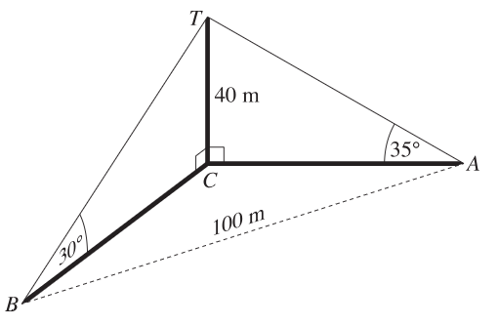

  - Show that distance AC is 57.13 metres, correct to 2 decimal places.
  - Find the bearing of B from C to the nearest degree.
$$a) In △TCA:$$
$$tan 35° =\frac{40}{AC}$$
$$AC =\frac{40}{\tan{35°}}$$
$$= 57.125...$$
$$= 57.13 m (2 d.p.)$$

$$b) In △TCB:$$
$$tan 30° =\frac{40}{BC}$$
$$BC =\frac{40}{\tan{30°}}$$
$$= 69.28 m$$

$$Find ∠BCA using cosine rule:$$
$$cos ∠BCA =\frac{{57.13}^{2}+ {69.28}^{2}- {100}^{2}}{2\left(57.13\right)\left(69.28\right)}$$
$$= -0.2446...$$
$$∠BCA = 104.2°$$
$$∴ Bearing of B from C = 90 + 104 = 194°$$

- From two points $P$ and $Q$ on level ground, the angles of elevation of the top $T$ of a 38 m tower are 26° and 22° respectively.
Point $P$ is due south of the tower, and the bearing of $Q$ from the tower is 100°T.
  - Show that $PB =38\tan{64°}$, and find a similar expression for $QB$.
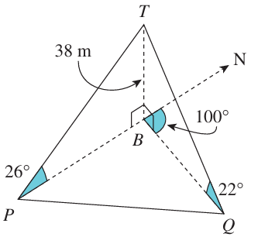
  - Hence determine, correct to the nearest metre, the distance between $P$ and $Q$.

a) 38 tan 68°
b) 111 m
- Two observers at $A$ and $B$ on horizontal ground are 300 m apart.
From $A$, the angle of elevation of the top $C$ of a tall building $DC$ is 32°.
It is also known that $∠DAB = 59°$ and $∠ADB=78°$.
  - Show that $AD =$ $\frac{300\sin{43°}}{\sin{78°}}$
  - Hence find the height of the building, correct to the nearest metre.
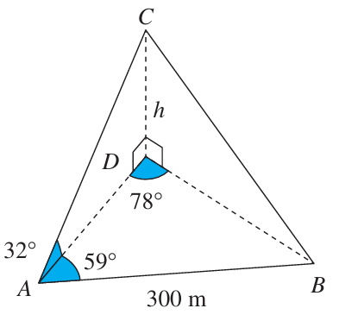

131 m

- HSC Sample Question Band 5
A cube ABCDEFGH is pictured below. R, S, and T are the midpoints of AB, FG and EH as shown. Side length = 10.
Calculate the size of the angle TRS, giving your answer to one decimal place.
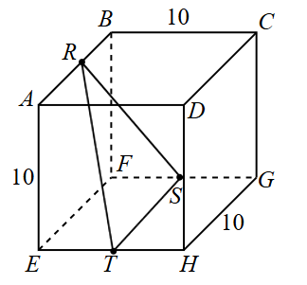
$$ST = 10$$
$$Find RT using △RQT where Q is the midpoint of EF:$$
$$RQ = 10, QE = ET = 5$$
$$QT = \sqrt{5^{2}+ 5^{2}}= \sqrt{50}$$
$$RT = \sqrt{{10}^{2}+ {\left(\sqrt{50}\right)}^{2}}= \sqrt{150}$$
$$By symmetry, RS = \sqrt{150}$$
$$Using cosine rule in △RST:$$
$$cos ∠TRS =\frac{{\left(\sqrt{150}\right)}^{2}+ {\left(\sqrt{150}\right)}^{2}- {10}^{2}}{2 × \sqrt{150}× \sqrt{150}}=\frac{2}{3}$$
$$∴ ∠TRS = \cos^{-1}\left(\frac{2}{3}\right)= 41.18…° = 41.2°$$

- HSC Sample Question Band 6
A tower is built on flat ground.
Three tourists, A, B and C are observing the tower from ground level. A is due north of the tower, C is due east and B is on the line of sight from A to C and between them.
The angles of elevation of the top of the tower from A, B and C are 26°, 28° and 30°, respectively.
What is the bearing of B from the tower?
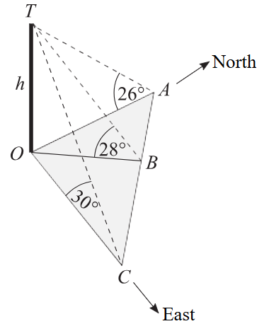

$$Let h = height of tower$$
$$In △OAT:\tan{26}° =\frac{h}{d_{A}}$$
$$d_{A}=\frac{h}{tan}26°$$
$$Similarly, d_{B}=\frac{h}{tan}28°, d_{C}=\frac{h}{tan}30°$$

$$In △OAC (right-angled, A due north, C due east):$$
$$tan ∠OAC =\frac{d_{C}}{d_{A}}=\frac{\frac{h}{\tan{30°}}}{\frac{h}{\tan{26°}}}= \frac{tan 26°}{\tan{30°}} = 0.8447…$$
$$∠OAC = 40.19°$$

$$Using sine rule in △OAB:$$
$$sin \frac{∠ABO}{d_{A}}= sin \frac{∠OAC}{d_{B}}$$
$$sin ∠ABO = sin 40.2°× \frac{tan 28°}{\tan{26°}} = 0.7035…$$
$$∠ABO = 44.71° or 135.29°$$

$$Since ∠OCA = \tan^{-1}\left(\frac{\tan{30}°}{\tan{26}°}\right)= 49.8°$$
$$∠OBC = 44.71° (otherwise angle sum △OBC > 180°)$$
$$∠AOB = 180 - (40.19 + 135.29) = 4.52°$$
$$∴ Bearing of B from tower = 005°$$

